Rashenda Dwwond Price
Abt. 1978 – August 7, 2025

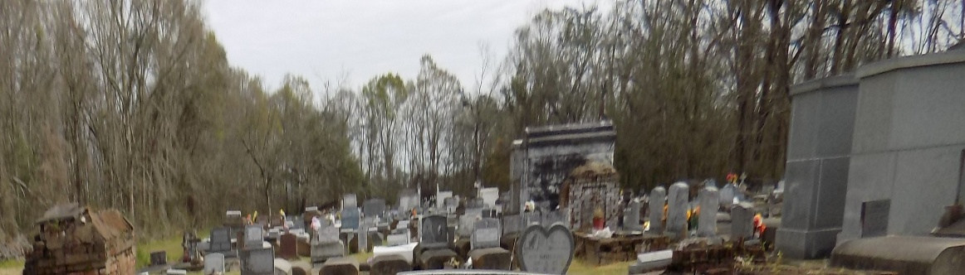

Rashenda Dewond Price, a native and resident of Convent, LA, peacefully transitioned into eternal rest on Thursday, August 7, 2025, at the very young age of 47. She was the daughter of Kim (Tommy) Hilliard and Nathan (Pamela) Price; the beloved mother of Khilar Price and Markhi Martin; devoted companion of Mark Martin; sister of Rocshand (Markeisha) Johnson, India Price, Lashun Johnson, Tommy Hilliard Jr., Thomas Hilliard and Tony Hilliard.
After graduating from Lutcher High School, Rashenda’s thirst for knowledge could not be quenched. Whenever any topic caught her interest, she would enroll in a course – somewhere, anywhere! – to educate herself on that subject. Over the years, she attended Cameron College, Nicholls State University, Delgado Community College and Xavier University. No institution of higher learning was too large or too small, too near or too far.
Shenda, as she was affectionately known, began her work career at St. James Parish Sheriff’s Office and like so many others in the River Parishes, she found herself working at Shell/Motiva in Norco, Louisiana, and later Dow Pipeline Grand Bayou Operations. Shenda remained a faithful and reliable employee at Dow until the time of her death. Her many, many co-workers and colleagues can attest to her jovial spirit, keeping everyone entertained during their long 12-hour shifts. They miss her already.
The New Orleans Saints, the New Orleans Pelicans, the Southern University Jaguars nor the Tulane Green Wave could have conjured up a more loyal fanatic if they tried, and while the word fan would be more commonly used, it was an entirely inadequate word when it came to describing Rashenda Price!! For years and years Shenda had season tickets for the New Orleans Saints and for the New Orleans Pelicans and she regularly attended Southern University football games with her aunt Tavish, a former SU Dancing Doll, traveling to see the Jags play, even when they played games on the road. Eventually Shenda’s son Markhi became a member of Southern University’s world-renowned Human Jukebox and Shenda’s pride could not be contained. Attending Jaguar football games, home and away, took on even more meaning as she got to watch her beloved Jaguars play, all while delighting at the sight of her Big Baby Boy performing during halftime shows. No greater happiness could she find. It was at Tulane Green Wave football home games, however, where Rashenda Price could be found with her cousin Devon on the sidelines of the field – yes, on the field! – chatting it up with players and coaches alike. Shenda was known to heap praise on the players when they played well and yet consoled them when they didn’t. She offered advice to the coaches (mostly unsolicited!) when she thought it was necessary and often wondered why she wasn’t offered some sort of coaching contract!
Her favorite pastime was playing bingo. She carried a bingo game in the trunk of her car and whenever the family gathered everyone, EVERYONE, played bingo, whether they wanted to or not! Rashenda had a larger than life personality. She was so outgoing and friendly that no one who knew her would have blinked an eye had she been caught talking to a lamp post!
She leaves to cherish her many precious memories her parents, children, and life partner; great aunts Diane Jacque and Lillian Price; uncles Thomas (Thelma) Price Jr., Charles (Sandra) Johnson, Johnny Price and Edwin Price; aunts Sharon Bradstreet, Gail Brown, Jacquelyn Johnson, Inez Walker, Sondia (Isaac) Chatman, Tavish Russell and Kimberly Price; and a host of nieces, nephews and many devoted cousins. We love you and you will be dearly missed.
Rashenda was preceded in death by her paternal grandparents Carmel and Clifford Gautreaux and Thomas Price Sr.; maternal grandparents Clara and Junious Johnson; and uncles Farrell Johnson, Johnny Price, Vincent Price and Wendell Price.
A Mass of Christian Burial will be held on Saturday, August 16, 2025 at St. Michael the Archangel Catholic Church, 6476 LA Hwy 44, Convent, Louisiana 70763. Visitation from 9am - 11am followed by Mass for 11am. Entombment St. Michael the Archangel Catholic Church Cemetery.

Treasures of Life Funeral Services, 315 E. Airline Hwy., Gramercy, LA
August 19, 2025

