Audry Joseph Rome Jr.
Abt. 1941 – February 2, 2025

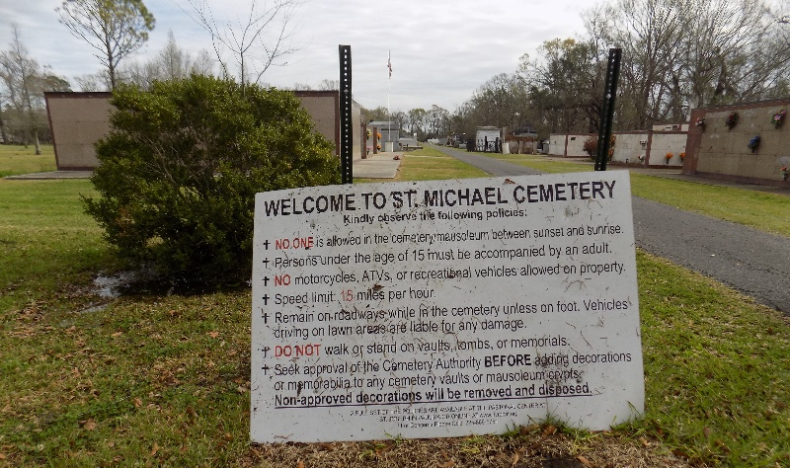

Audry Joseph Rome Jr., a lifelong resident of Romeville, passed away on February 2, 2025, at the age of 84.
He is survived by his two children, Dean (Mel) Rome and Lori (Mark) Gauthier; precious grandchildren, Blake (Dees) Rome, Brooke (Paul) Faucheux, Evan (Chelse) Rome, Olivia Rome, Josh Gauthier and Josie Gauthier; great grandchildren, Emmie, Kinsey, Bentley, Parker, and Breigh; siblings, William, Fernand "Tnook", Carol Ann Rome, Sadie Carey, Margaret Bedard (Hector), and Gayle "Bozo" (Mary Ann); and in-laws, Alise Henderson (Bob), Carol Lambert, Jane Copponex, Pat Copponex, Charleen Lambert, and Charles DiLeo.
Preceded in death by the love of his life, Joyce Copponex Rome; his son, Raymond Jude Rome; parents, Audry Rome Sr. and Frances Levet Rome; in-laws, Ulrich and Alice Copponex; sister, Lillie DiLeo; sister-in-law, Nancy Rome; brother-in-laws, Lloyd Carey, Ulrich Copponex Jr., Edward Copponex, and Calvin "Pnut" Copponex; uncles, Donald "Pete" and Gerald Levet.
He was a great husband, father, grandfather, great-grandfather, brother, brother-in-law and friend to all who knew him. A Christian man of many words that always put his family first. He had a love for carpentry and was very proud of the house he built for his family. He was Valedictorian of Romeville High School, Class of 1958 and was well known by many through Hymel's grocery store which he managed for over 24 years.
Relatives and friends are invited to attend the Visitation and Funeral Mass at St. Michael the Archangel Catholic Church, 6484 LA-44, Convent, LA on Friday, February 7, 2025. Visitation will be held at the church from 9:00 a.m. to 12:00 p.m. with the rosary starting at 8:30 a.m. followed by a Funeral Mass at 12:00 p.m. Entombment in St. Michael Church Mausoleum.
In lieu of flowers, donations can be made to St. Michael's Church Building Fund.

Rose Lynn Funeral Home, Lutcher, Louisiana

