Angela (Bergeron) Schexnaydre
November 28, 1948 - October 12, 2025

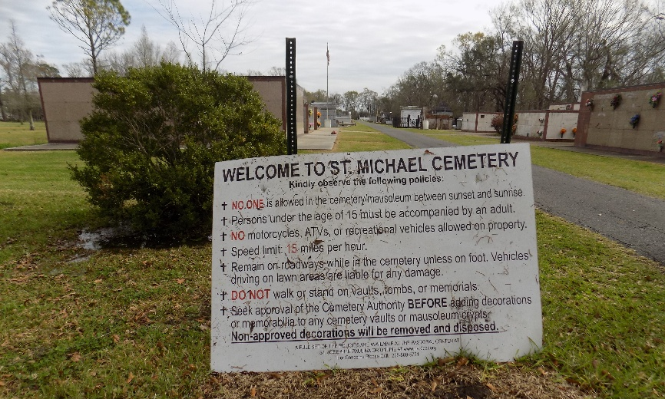

It is with profound sadness that the family of Angela Bergeron Schexnaydre announces her passing on October 12, 2025, at the age of 76. A lifetime resident of Convent, Louisiana, Angela was a devoted wife, mother and grandmother. She was a graduate of Romeville High School, class of 1966, and a former employee of Audubon Ford.
She was known for being a passionate animal lover and having an infectious sense of humor. She never met a stranger and loved spreading laughter. Her greatest joys came from spending time with her family, whether that meant watching her grandchildren at their sporting events, hosting a crawfish boil under her favorite oak tree, handing out candy during the annual Halloween party, or exchanging gifts at the family Christmas party. She also loved solving the daily cryptoquote and word jumble. It was always a race with her husband to see who could solve the puzzle first. Most importantly, Angela was child of God and prayed her rosary daily.
Angela is survived by her loving husband, Christopher Schexnaydre; her three children, Shannon St. Pierre (Brittany), Erin Campbell (Lance), and Kimberly St. Pierre; and her four grandchildren, Landry Campbell, Lyla Campbell, Knox St. Pierre, and Jack St. Pierre. She is also survived by siblings, Debra Andermann (Mark) and Dennis Bergeron, and numerous nieces and nephews. She will also be truly missed by her adoring pets Bella, Max, and Dixie Bell. She was preceded in death by her parents, John and Marie Bergeron, and her siblings Alice Robert, Valerie Chauvin, Johnny Bergeron, Elaine Gauthreaux, and James “Jimmy” Bergeron.
A visitation in her memory will be held on Friday, October 17, 2025, at St. Michael Catholic Church in Convent, LA, from 8:00 a.m. to 9:00 a.m. for family and from 9:00 a.m. until the funeral service at 11:00 a.m. for friends, followed by a Mass of Christian Burial. Interment will follow at St. Michael Catholic Church Cemetery. The family extends their heartfelt thanks for the love and support shown during this difficult time. Angela will be deeply missed by all who knew and loved her.

Rose Lynn Funeral Home, Lutcher, Louisiana
October 19, 2025

