Marlene Marie Schexnaydre
February 6, 1956 - January 5, 2026

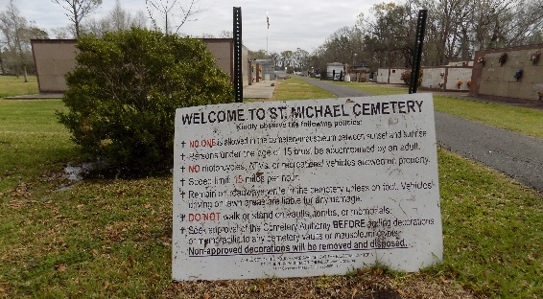

Marlene passed away Monday, January 5, 2026, from ALS disease at the Butterfly Wing Hospice Facility in Baton Rouge at the age of 69. She was born February 6, 1956, at the Tezcuco Plantation in Burnside, LA to the late Julian P. “Zoo” and Glory Letulle Schexnaydre. Known as “Moe” to her family, “MeMoe” to Blair, Brooklyn and Brock and “Queenie” to her therapist, she was the third of four siblings and was raised until the age of 14 on the Wilton Plantation in Convent, LA with numerous aunts, uncles and dozens of cousins. For the next 40 years she resided on Schexnaydre Street in Convent, LA. Marlene graduated in the last class (1974) of Romeville High School. She went on to a career in bookkeeping and accounting, working at several locations in Baton Rouge. She then worked for many years at the St. James Parish Courthouse as a Secretary for the LSU Co-op Extension Service and finally Roland J. Robert Distributors in Burnside, LA. For over 20 years, she also did the bookkeeping for her family’s sugar cane farm, Wilton Planting Company.
Marlene had a quiet demeanor, a kind heart to everyone and enjoyed painting her ceramics, going to movies with friends, eating out, and watching “laugh out loud” comedies. For many years, particularly after her father’s illness, Marlene chauffeured her parents and helped with their care. She will be missed dearly by all who knew and loved her.
Marlene is survived by her siblings, Julian P. “Junior” Schexnaydre and his wife Cindy; Roberta S. DuBois and her husband Terry, all of Gonzales, LA and Connie S. Frederic and her husband Patrick of Clinton, LA. She is also survived by 6 nieces and nephews: Jay Schexnaydre, Todd (Kristen) DuBois, Meché (Adam) DuBois, Crystal (Ernie) Matherne, Kip (Danny) Schexnaydre and Dirk Schexnaydre; and 6 great-nieces and great-nephews: Zoé C. Rickels, Blair A. Matherne, Brooklyn K. Matherne, Brock A. Matherne, Lily K. DuBois and Trace J. DuBois.
Visitation will be held on Tuesday, January 13th from 9:00 a.m. until 11:00 a.m. followed by a Mass of Christian Burial at 11:00 a.m., at St. Michael the Archangel Catholic Church in Convent, LA. Entombment to follow in the church mausoleum. The family would like to thank Grace Health and Rehab of Slaughter, LA for all their extensive care given to Marlene and spoiling her during her past few months and also to The Butterfly Wing at Baton Rouge General for showing their compassion during her final moments here with her family.

Charlet Funeral Home, Zachary, Louisiana

