Mary Louise (Barbier) Schiffers
June 6, 1915 – April 20, 2005

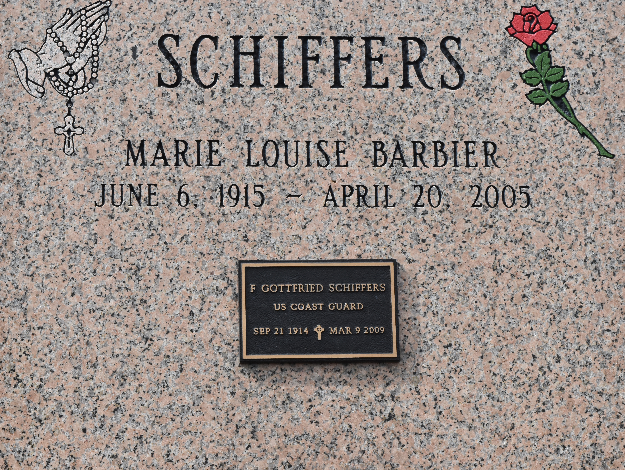

Louise Barbier Schiffers, a homemaker, died Wednesday at her son's home. She was 89. Mrs. Schiffers was born in Convent and lived in Lacombe for 40 years.

Survivors include her husband, Gottfried Schiffers; two sons, Kenneth G. and Ronald H. Schiffers; a brother, Louis J. Barbier of Largo, Fla.; and two grandchildren.

A Mass will be said today at 11 a.m. at St. Michael's Catholic Church, 6484 Louisiana 44, Convent. Visitation will begin at 10 a.m. Burial will be in the church cemetery. Honaker Funeral Home in Slidell is in charge of arrangements.

Times-Picayune, The (New Orleans, LA) - Thursday, April 21, 2005
Contributed by Jane Edson

