David Fitzgerald Shaw
May 3, 1965 - June 14, 2025

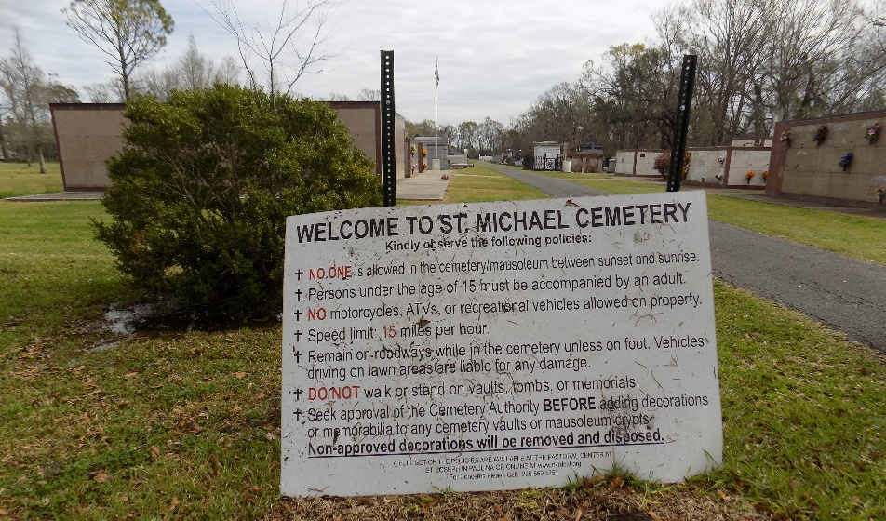

David was born to the union of Arthur Shaw and Juanita Maxine Donald Shaw in New Orleans, Louisiana. He attended St. Philip the Apostle Catholic School for his primary years and then matriculated to St. Augustine High School, where he graduated with the Class of 1983. After completing high school, David went on to attend Xavier University of Louisiana. During his high school and college years, David worked for McDonald's Corporation. Afterward, he taught French at St. Philip the Apostle School. He worked consistently with the Oblate Sisters of Providence, Marianite Sisters, Josephite Fathers, and the Archdiocese of New Orleans for several years.
David later secured a position at Lockheed Martin and worked there for many years. After a long tenure, he changed industries and began working at Tenet Healthcare as a Senior Director. During this time, he earned his Master of Health Administration/Business Administration degree from the University of Phoenix, graduating with honors. Before the onset of Hurricane Katrina, David accompanied his mother, stepfather, and sister to St. Louis, MO, to ensure their safety. After exploring multiple job opportunities, he decided to relocate to Dallas, TX, which became his primary residence. Eventually, David accepted a special assignment in his birthplace of New Orleans, LA, serving as Director of Patient Access at LCMC Health University Medical Center New Orleans Clinics.
In his spare time, David enjoyed traveling. He especially looked forward to his annual Halloween cruise and trips to Palm Springs, among other destinations. He also shared his passion for fashion by working at K & G Fashion Superstore, serving the Greater New Orleans and Metairie areas. David was a dedicated employee and team leader until his transition. A devout Catholic, David regularly attended Mass at St. Raymond/St. Leo the Great Church. He transitioned from this life on June 14, 2025, at his residence in New Orleans, LA.
David was a devoted son, brother, uncle, godfather, brother-in-law, friend, leader, and co-worker. David is preceded in death by his maternal grandparents, Warren Joseph Donald Sr. and Bishop Hilda Aline Cathalina Donald; his paternal grandparents, George and Vera Shaw; and his uncle, Warren Joseph Donald Jr. He leaves to cherish his memory his partner of 22 years, Derric Douglas of Dallas, TX; his mother and stepfather, Bishop Juanita Donald Brandon and Frankie Lee Brandon; his father, Arthur Shaw; his siblings: Arthur Michael Anthony (Danielle), Ann Erin Elizabeth (Dwayne Ward), and Versile James John (René) Shaw; and his stepbrother, Tramaine Williams. He is also survived by former sister-in-law Lisa Johnson Shaw; nieces and nephews: Michael Isaac, Jordan Michaiah, Verselé Juanita, James John, and Paris René Shaw; aunts and uncles: Olive (Willie Jr.) McCloud, Yvonne Lewis (Fred Martino), Arnold (Hazel) Donald, Patricia Donald, Eugene Jones, Veretta, Veronica, Hildagard, Vera Odessa, Viola, and George Shaw III; and a host of relatives, godchildren, friends, co-workers, and members of the Sacred Heart of Jesus Family and St. Michael Temple of the Expanded Mind, Archbishop Michael A. West (St. Louis, MO).
Funeral arrangements have been entrusted to Richardson Funeral Home of Jefferson Inc., River Ridge, LA. A Christian Mass will be held at St. Martin de Porres Catholic Church, located at 5621 Elysian Fields, New Orleans, LA 70122 on Wednesday, June 25, 2025 at 11:00 am. Viewing will begin at 9:30 am. Interment will follow at St. Michael's Cemetery, located at 6484 LA-44 in Convent, LA. A repast will follow the Christian burial at St. Augustine High School, located at 2600 A.P. Tureaud Ave., New Orleans, LA 70119.

Richardson Funeral Home, River Ridge, Louisiana

