Joyce (Accardo) Stone

July 19, 1932 – October 15, 2021

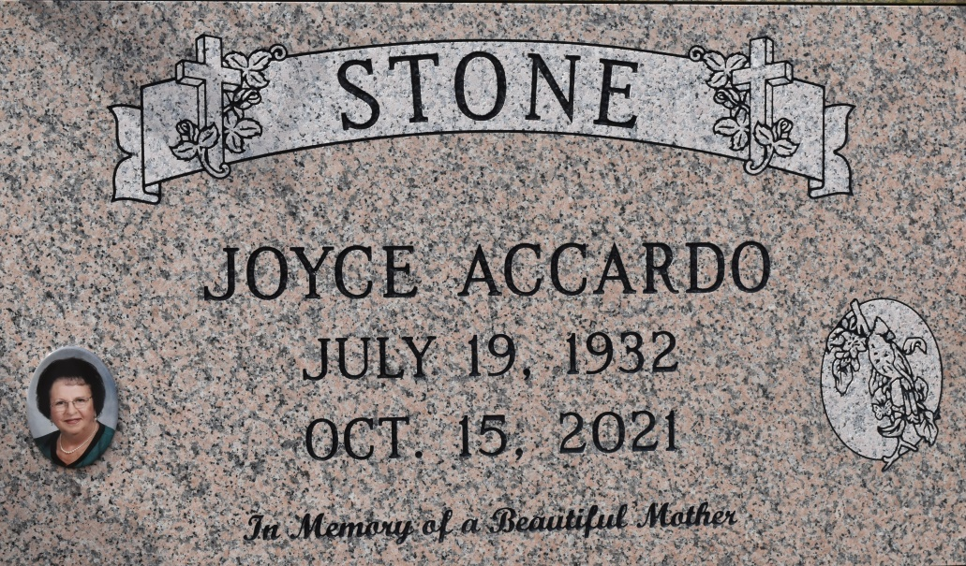

Joyce Accardo Stone, a native of Hester, LA and a resident of Gramercy, LA, passed away on October 15, 2021 at the age 89.

Joyce loved planting beautiful flowers in her gardens and traveling with her family.  She was a kind and generous soul who loved helping people in any way that she could.  Most of all, she was very strong in her faith.

Joyce is survived by her daughter, Karla Stone Beck (Michael Jr.) and grandchildren, Taylor Michael Naquin and Michael Jacob Beck III.

She is preceded in death by her husband, Gerald Rome; parents, Michel and Florence Accardo; and sister, Patricia Accardo Kliebert.

A visitation will be held at St. Michael Church in Convent, LA on Thursday, October 21, 2021 from 9:00 AM until 11:00 AM followed by a Mass of Christian Burial.  Interment will take place at St. Michael Cemetery in Convent, LA.

Special thanks to Ricky and June Accardo, Jan Bevil, Jeanne Bourgeois, Rhonda Lee, Holden Bourgeois, Marcy Herrington and family, and all her wonderful family and friends whom she loved so much.

Rose Lynn Funeral Home

Lutcher, Louisiana