Mary Ann Taylor
October 12, 1947 – February 1, 2023

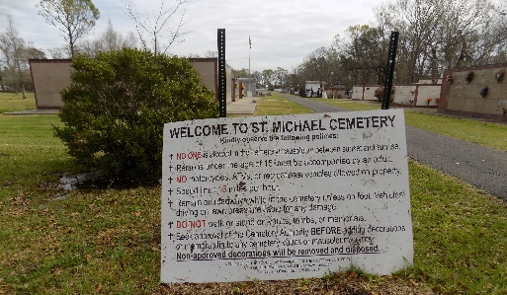
Mary Ann Taylor entered eternal rest on Wednesday, February 1, 2023, at Our Lady of the Lake Medical Center in Baton Rouge, LA at the age of 75. Mary Ann was born on October 12, 1947, to the late Annie Louise Smith Taylor and Willie Taylor, Sr. in New Orleans, LA. Mary Ann was a resident of Laplace, LA and a native of Lutcher, LA.
At an early age, Mary Ann confessed Jesus Christ as her Lord and Savior and was baptized at Golden Grove Baptist Church by the late Rev. Charlie Stewart. She later joined New Zion Christian Center under the leadership of Elder Emil Dean Mitchell, Sr. Mary Ann was educated in the St. James Parish School System. She attended Cypress Grove High School in Lutcher, LA. For many years, Mary Ann worked at Holiday Inn in Kenner, LA and at Guardsmark in Norco, LA.
Mary Ann leaves to cherish her life's memories to her children: Eric Taylor, Sr. (Anita); Sandra Taylor Martin (Theron Sr.); sister, Exie Taylor Payne; one brother-in-law, Freddie Kelson; two sisters-in-law, Gertrude Taylor and Georgia Taylor; seven grandchildren: Sandrika Mitchell, Kamryn Goff, Mariah Taylor Mason (Demond Sr.), Eric Taylor, Jr. (Domonique), Tracey Ann Mitchell, Theron Martin, Jr., and Tanae Martin.; four godchildren: Keyetta Jackson, Rena Jackson, Syble and Thomas Hoyal; two devoted friends, Sandra Jenkins and Laura Joseph; nine great-grandchildren, a host of nieces, nephews, other relatives and friends.
Mary Ann Taylor was preceded in death by her parents, Willie Taylor and Annie Louise Smith Taylor: three sisters: Betty Lee Taylor; Bernice Kelson and Syble Taylor; six brothers: Willie Mack Taylor, Lawrence Taylor, Joe Frank Taylor, David Taylor, Samuel Taylor and Major Lee Taylor.
Pastors, officers and members of New Zion Christian Center and neighboring churches, and relatives and friends of the family are invited to attend the homegoing celebration on Saturday, February 18, 2023, at 11:00 am at New Zion Christian Center, 216 W. Main St., Gramercy, LA 70052. Pastor Emil Dean Mitchell, Sr. officiating. Visitation will be at the above-named church from 9:00 am until service time. Interment will be at St. Michael Cemetery, Convent, LA. Viewing will be held on Friday, February 17, 2023, from 3:00 pm- 6:00 pm at Bardell's Mortuary, 3856 LA-44, Mt. Airy, La. 70076.
The Advocate, Baton Rouge, Louisiana
Feb. 17, 2023

