Floristine (Celestin) Van Court

March 21, 1919 – December 29, 2009

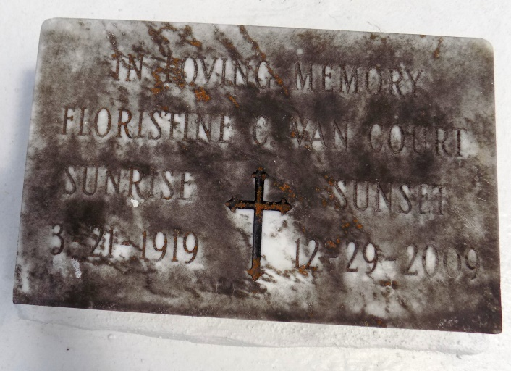

Floristine Celestin Van Court entered into eternal life on Tuesday, December 29, 2009. Loving wife for 63 years of the late Herman J. Van Court. Devoted mother of Herman R. (Yvonne) Van Court, Ulysses (Andrea) Van Court, Glinda V. (Joseph, Jr.) Morton, and Althea V. Druhet. Daughter of the late Leonard Celestin and Carrie Brown Celestin, also survived by a host of grandchildren, great grandchildren, other relatives and friends. Special thanks to Heart of Hospice. Age 90 years, a native of Ascension Parish, La. and a resident of Gretna, La.

Relatives and friends of the family, also priest and parishioners of All Saints Catholic Church, pastors, officers, and members of Morning Star B.C. and neighboring churches; Employees of Tonti Management, J C Penney Oakwood, and Bollinger Shipyard are invited to attend the Mass of Christian Burial at All Saints Catholic Church, 1441 Teche St., Algiers, La., on Monday, January 4, 2010 at 10:00a.m. Visitation will begin at 8:00a.m. and recitation of the rosary at 9:30a.m. at the above named church. Interment: St. Michael's Cemetery, Hwy 44, Convent, La. Arrangements by Davis Mortuary Service, 230 Monroe St., Gretna, La.

The Times-Picayune, New Orleans, Louisiana

Jan. 3, 2010