May Walterine (Porter) Wagner

May 5, 1919 – February 14, 2006

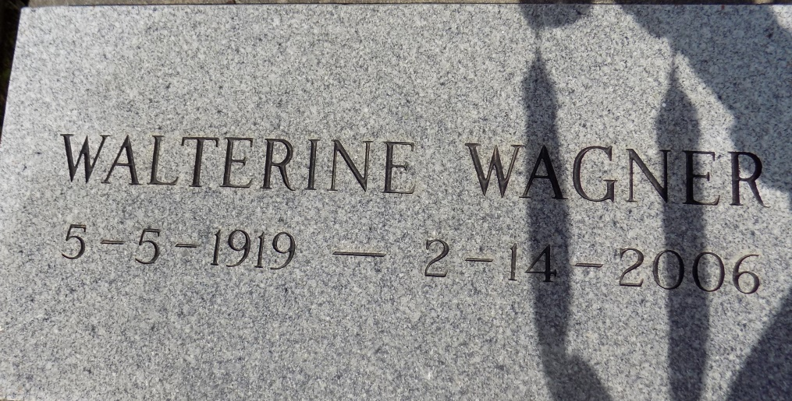

May Walterine Porter Wagner, was called to Eternal Rest on Tuesday, February 14, 2006, at 10:30 P.M. A native of Convent, LA and resident of New Orleans, LA and New York, but later resided in New Orleans, LA, where she died. She was blessed with 86 years of life and was preceded in death by her late husband, Daniel Wagner; her parents, Eugene Porter and Marie Jacque Porter; two sisters, Elvira P. Philips and Fabiola Porter Terry, and 1 brother, Eugene Porter, Jr.

Visitation will be at St. Michael the Archangel Catholic Church, in East St. James Parish, 6490 Highway 44, Convent, LA 70723, on Wednesday, February 22, 2006, from 9 A.M. - 11 A.M. Father Frank Uter, Celebrant. Arrangements by D.W. RHODES FUNERAL HOME

The Times-Picayune, New Orleans, Louisiana

Feb. 21, 2006