Kenneth E. Watson
December 12, 1950 - November 8, 2025

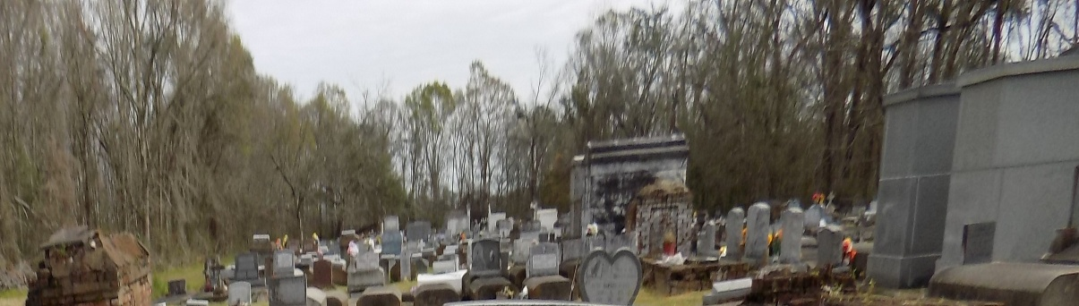

Kenneth E. Watson departed his earthly life on November 8, 2025, age 74. Kenneth was born on December 12, 1950, to Florida Gaines Watson and Albert Watson, Sr. He was raised in Lutcher LA along with his siblings Ira Donald, Glynettee Martin, Ivan Watson, Robert Watson and the late Irma Jean Stevens, Craig Turner, Lynette Watson, Albert Watson, Jr., and Raymond Watson.
As he grew from a boy to a man he met and married Linda Marie Roberts, together they raised two beautiful baby girls Quiness and Raynika with the addition of five grandchildren; Ma'Kayla, Blakelyn, Dylan, Matthias, Landon and great grandchild Amir.
As life went on, he became an over the road truck driver and dedicated 31 years of his life to learning and teaching others how to drive safely to make it home to their families. He met many people during his career. As a truck driver, he and some became lifelong friends.
Kenneth was a man who spoke what was on his mind and did not care if you agreed...lol. However, he was also a man that would show up and help those he cared for, a man who taught life lessons by sharing his stories. He loved spending time with his grandchildren and having get togethers with family. I wish he could have enjoyed that rabbit and to have seen Amir with the BBQ drumstick...if you know you know.
He enjoyed tailgating at Southern University football games and met many people during those games that became friends. He was sometimes the loudest one in the stands and enjoyed sitting with opposing teams, laughing and heckling them. Those things may not be important to you. However, these were the things he loved and shaped him into the person we all knew. No matter how you met Kenneth, he made sure you remembered something about him.
Over the upcoming days, weeks, months, and years, hold on to the memories you have of him. When you are at a football game, shout GO Jags in honor of him, when you are spending time with your family, know that he is smiling, because that is what made him happy.
He leaves his memories to be treasured by his daughters, Quiness and Raynika, 5 grandchildren, 1 great grandchild, his siblings, and two sisters-in-law and one brother-in-law, a god daughter and numerous nieces, nephews, other relatives and friends.
Kenneth was preceded in death by his parents Albert, Sr. and Florida Watson. His siblings, Irma Jean Stevens, Craig Turner, Lynette Watson, Albert Watson, Jr., Raymond Watson and his nephew Frederick Williams, Jr.
Relatives, friends of the family, Priest and parishioners of Our Lady of Grace Catholic Church and all neighboring Churches are invited to the Mass of Christian Burial at 10:00am on Monday, November 17, 2025, at Our Lady of Grace Catholic Church, 772 LA-44, Reserve, LA 70084. Visitation 8:00am until the time of Mass at the above-named Church. Interment St. Michael the Archangel Catholic Church, 6484 LA-44, Convent, LA 70723.

Patrick H. Sanders Funeral Home, Laplace, Louisiana

