Lawrence James Watson Sr.
Abt. 1948 – October 19, 2025

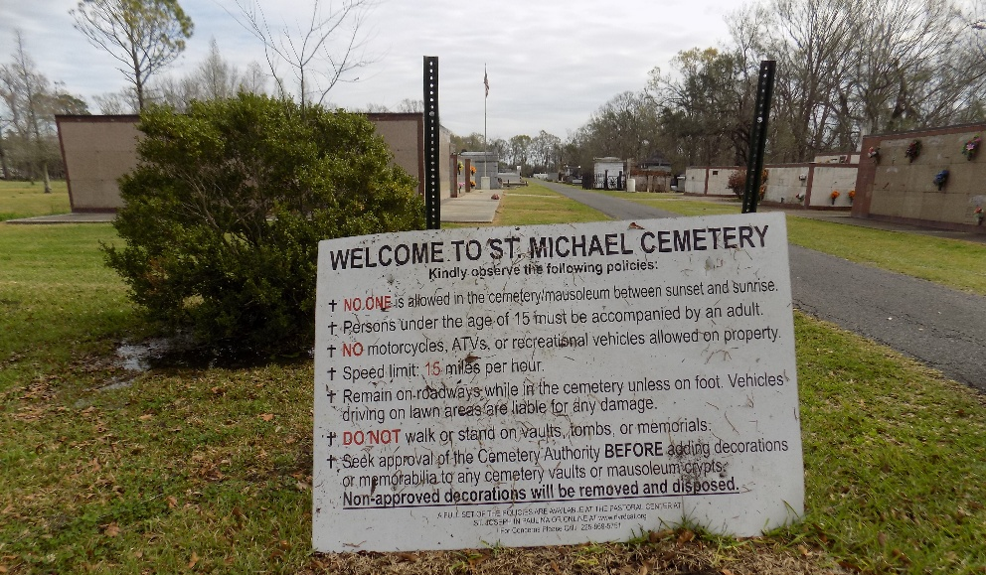

Lawrence James Watson, Sr., affectionately known as "Boss Hogg" passed away peacefully on Sunday, October 19, 2025 at Chateau St. James Nursing Home in Lutcher, surrounded by his loving family. He was 77.
Visiting at King David Baptist Church, King Avenue, Lutcher on Saturday, October 25, 2025 from 9:30 a.m. until Religious Services at 11:00 a.m. conducted by Rev. Louis Watson. Interment in St, Michael's Cemetery in Convent.
Survived by his wife, Darlene Stewart Watson. Daughters, Alesha (Byron) Grow, Kordice Watson, Ariene Lewis, and Ashley Woodland. His sons,
Lawrence (Tequilla) Watson, Jr. and Lance Woodland. Sister, Wilma Sue (George) Weber, Sr. Brother, Stanley Watson. Sisters-in-law, Arlene McDonald and Delores (Darnell) Jones. Also 9 grandchildren, 20 great-grandchildren and numerous nieces, nephews, cousins, other relatives and friends. Family members are asked to wear black and crimson red.
Preceded in death by his parents, Handy Clifton Watson, and Pearl Harris Watson. Sister, Rose Marie (Lionel) Griffin. Brother. Glen Watson. His mother-in-law, Maeola Collins. His daughter, Sheletha Woodland.
No repass will be held.

Brazier-Watson Funeral Home, Donaldsonville, Louisiana

