Abraham Jude Adams Jr.
May 26, 1938 – August 15, 2013

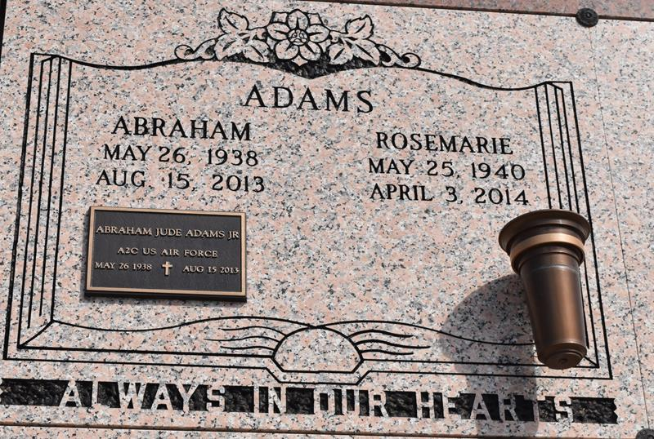

ADAMS Abraham "Abe" Adams, Jr., passed away Thursday, August 15, 2013, at the age of 75 years old.
Son of the late Isabele and Abraham Adams, Sr. Husband of Rose Marie Adams. Father of Michael ( Rhonda) Harris, Robert (Gail) Adams, Angela (David) Belfield, Saundra (Sam) Bethel, Robin Adams, Brian (Treva) Hackett, and the late David Adams. Brother of Terrel Adams, Ranaldo Gauthier, Sandra (Warner) Sylvain, Kebin Adams, and the late Donald Adams, Raymond Adams, Rosemarie Johnson, Beverly Williams, and Barbara Gauthier. Brother-in-law of Elizabeth Warren, Mary Shepard, and Daniel Mitchell. Also survived by a host of grandchildren, nieces, nephews, cousins, other relatives and friends.
Funeral services will held at St. Phillp Catholic Church, 1175 Highway 18, Vacherie, La., on Thursday, August 22, 2013 at 11:00 a.m. Visitation will be from 9:00 a.m. until time of service. Rosary will begin at 9:30 a.m. Father Brent Maher will be officiating. Interment will be at St. Phillip Cemetery, Vacherie, La.
Funeral entrusted to The Baloney Funeral Home, LLC., 1905 W. Airline Highway, Laplace, La., 985-224-8460. Condolences can be expressed at www.baloneyfuneralhome.com.

The Times-Picayune, New Orleans, Louisiana
Aug. 20 to Aug. 21, 2013

