Pamella (Weber) Adams
July 31, 1925 – August 18, 1998

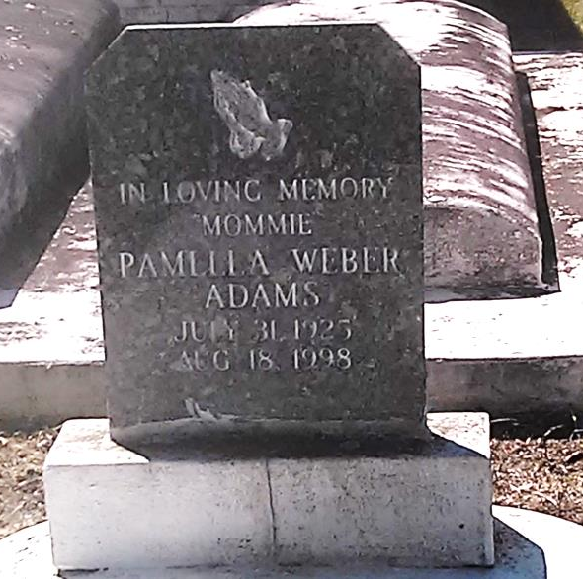
Photo by TMB

Pamella Weber Adams, a retired St. James Parish schoolteacher, died Tuesday at St. James Parish Hospital in Lutcher. She was 73. Mrs. Adams was born in Baytree in St. James Parish and lived in Wallace for many years. Survivors include her husband, Bernard Adams Sr.; two sons, Bernard Adams Jr. of St. James and Charles Adams Sr. of LaPlace; two daughters, Iris Adams Johnson of New Orleans and Leslie Adams Griffin of LaPlace; a brother, August Weber of New Orleans; two sisters, Shirley Priestley of New Orleans and Cora Oubre; 20 grandchildren; and 16 great-grandchildren.

Unknown source

