Christopher Jude Allen
October 10, 1985 – July 5, 2025

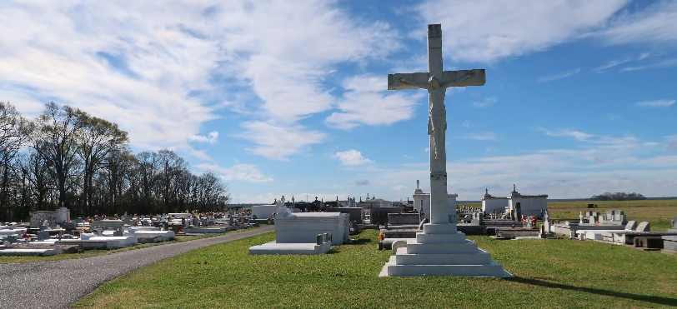

With shattered hearts and eternal love, we announce the passing of our beloved Christopher Jude Allen, who departed this life at the age of 39, at home and in the presence of those who loved him most. Born on October 10, 1985, in the heart of Thibodaux, La., Chris was the son of Finley Allen and Myra Dumas Allen, and the cherished brother and best friend of Dymphna R. Allen. From the very beginning, Chris carried contagious joy, a laughter that echoed, and a light that lingered. Chris was the kind of soul you don’t just meet, you remember. He had a gift for turning strangers into friends and friends into family. Known for his jolly spirit and boundless generosity, Chris lit up every room he entered with love and warmth. His connection to his family was unshakable, and his bond with his sister was one few ever get to experience in this life — a true friendship rooted in unconditional love. He was an artist at heart and a marvel in the world of graphic design — able to bring ideas to life with extraordinary creativity. He had a passion for video games, movies, gadgets, and tech, always curious, always exploring. And whether he was playing the newest game, planning a quick getaway, or simply sitting in the middle of a family gathering with a smile on his face, Chris lived in the little moments…the ones that matter most.
Chris attended Southern and Louisiana State University. He went on to become a beloved store manager at Lids in Baton Rouge, where he was more than just a manager — he was a source of joy for his coworkers and customers alike. His compassion and kindness touched everyone he met. He made people feel seen. He made people feel welcomed and loved.
Chris leaves behind a family who adored him beyond measure: his parents, Finley and Myra Allen; his sister and best friend, Dymphna Allen; and his treasured nephew and godchild, Amon Broden, His uncles: Alexander Allen, Jr. (Geo),Quincy Allen (Valerie), Rodney Allen (Mary), Bernard Dumas, Jr. (Yolanda), Dwight Dumas, Sr., Mark W. Dumas, Terrance P. Dumas. His aunts: Trudy Dumas Steib (Rickie), Godmother Andrea F. Dumas, Geralyn H. Dumas, Stacey L. Dumas (John), and a host of great uncles, aunts, and cousins.
He now joins in eternal rest his grandparents- Bernard and Esther Saul Dumas, Alexander Allen Sr. And Jessie Mae Combre Allen. Aunts: Malinda Stewart and Karen Lynn Dumas, embracing them in Heaven with the same love he gave so freely here on earth. To know Chris was to feel joy. To lose him is to carry a sorrow that cannot be put into words, a hollow space that can only be filled by continuing to love, laugh, and live the way he did. Though he is no longer here in body, his presence will be felt forever in our stories, our hearts, and the invisible ways he’ll always walk beside us.
Family and Friends will gather on Wednesday, July 16, 2025 at Treasures of Life Funeral Services, 315 E. Airline Hwy., Gramercy, LA 70052 from 5pm to 7pm. A Mass of Christian Burial will be held on Thursday, July 17, 2025 at St. Philip Catholic Church,1175 LA-18, Vacherie, LA 70090. Visitation is from 9am to 11am; followed by Mass at 11am. Interment St. Philip Catholic Church Cemetery.

Treasures of Life Funeral Services, Gramercy, Louisiana
Jul. 14, 2025

