Alton Joseph Armant

August 23, 1949 – May 28, 2016

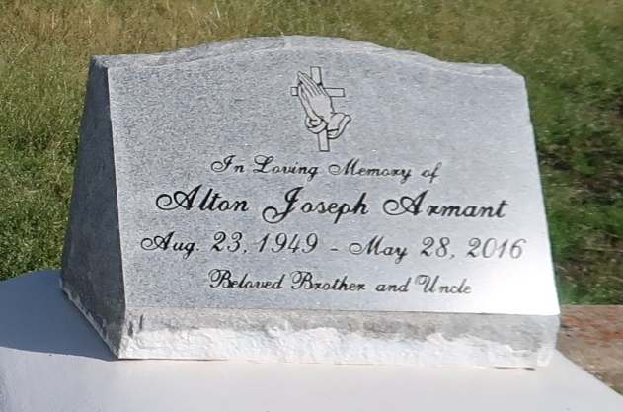

Alton Armant on Saturday, May 28, 2016 at his home in New Orleans, LA Son of the late Elvira Bradley and Wilfred Armant, Sr. Brother of Gregory Armant, Melinda Armant, Darleen Armant, Veronica Griffin, the late Wilfred Armant, Jr. and Ellenor Armant. Also survived by a host of nieces, nephews, cousins, other relatives and friends. Age 66 years. A native of Wallace, LA and a resident of New Orleans, LA.

Relative and friends of the family, also priest and parishioners of St. Phillip Catholic Church and all neighboring churches are invited to attend the Funeral Mass at St. Phillip Catholic Church, 1175 River Road, Vacherie, LA on Monday, June 6, 2016 at 11:00 AM Father Chris Decker, Celebrant. Interment St Phillip Catholic Church Cemetery, Vacherie, LA. Visitation at the above named church from 9:00 AM until Mass time. Rosary at 9:30 AM SERVICED BY ROBOTTOM.

Published by The Times-Picayune from Jun. 3 to Jun. 5, 2016.