Odette Marie (Cazenave) Babin

August 18, 1895 – January 11, 1979

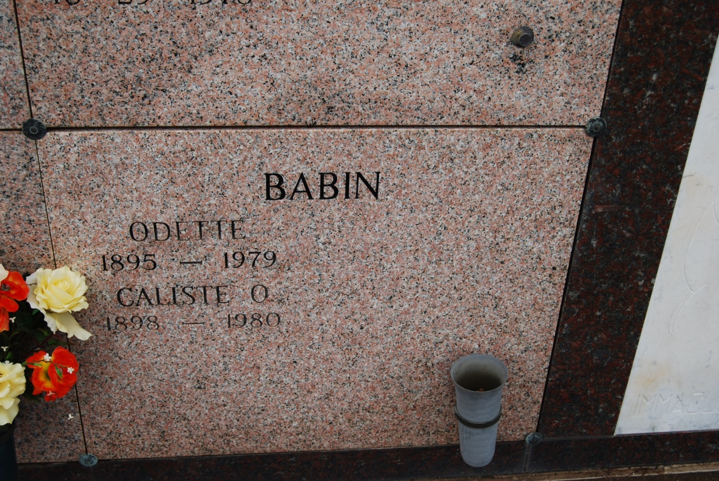

Photo by Kerry Keller

Odette Marie Cazenave Babin, a native of Vacherie and resident of Houma,  
died Jan 11 at 5:10 pm at her residence at the age of 83.  
 Visitation at Chauvin Funeral Home will begin today at 5 pm at and will  
continue until 11 pm, resuming at 8 am until funeral time. Funeral services  
are scheduled for Saturday Jan 13 at 10 am at the Chauvin Funeral Home  
Chapel, followed by interment in St. Philip Cemetery.  
 She is survived by her husband, Caliste Babin and three sisters, Mrs. Mercedes Tassin of Vacherie, Mrs. Julie Fauchaux of Vacherie and Mrs. Odile Raptier of New Orleans.  
 She was preceded in death by her parents, Joseph and Malvina Abadie Cazenave.  
 Chauvin Funeral Home is handling arrangements.

Courier; Houma, Terrebonne Parish, LA  
Friday, January 12, 1979   
Submitted by Cynthia F. Daigle