Rose Marie Burke

September 29, 1959 – July 17, 2016

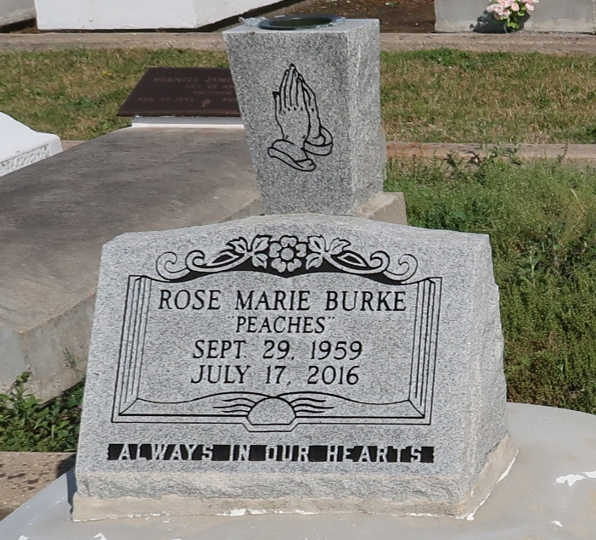

Rose Burke "Peaches" departed this life on Sunday, July 17, 2016 at the age of 56. Daughter of the late Larry Burke Sr. and Jean Marie Landreaux Burke. Sister of Martha Woods (Amos), Larry Burke, Jr., Darren Burke (Marlene) and Herman Charles, Jr. She is also survived by special cousins, Debra Celestine and Pat Burke Kilbert; a devoted friend, Claudette Luke and a host of other relatives and friends.

Relatives and friends of the family also priest and parishioners of St. Phillip Catholic Church are invited to attend a Funeral Mass of Christian Burial at St. Phillip Catholic Church, 1175 Louisiana Hwy. 18, Vacherie, LA on Friday, July 22, 2016 at 11:00 a.m. Visitation 8:00 a.m. Father Alex Shelton officiating. Interment: St. Phillip Catholic Church Cemetery. Arrangements by D.W. Rhodes Funeral Home 3933 Washington Ave. Please visit [www.rhodesfuneral.com](http://www.rhodesfuneral.com/) to sign the online guestbook.

Published by The Times-Picayune (LA) from Jul. 20 to Jul. 22, 2016.