Jerry Joseph Clark
June 4, 1954 – August 22, 2025

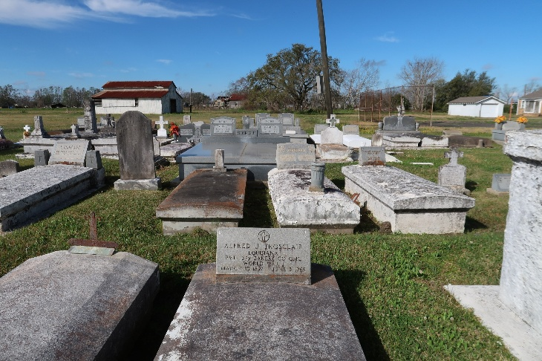

Jerry Joseph Clark was born on June 4, 1954. He was the fifth of ten children born to Miller and Celeste Clark. His siblings include Euris, James, Mallory, Catherine, Perry Clark, Debra Washington, Sharleane Stewart, Ann Williams and Beverly Hayes. Jerry was baptized into the Catholic faith at St. Phillip Catholic Church. He was a graduate of Edgard High School where he played numerous sports. He attended Nicholls University for a brief period and then joined the U.S. Armed Forces. Jerry returned home and worked several jobs. His last being at Avondale Shipyards.
Jerry married the love of his life, Vickie Lewis, on December 31, 1996. From this union two loving children were born: Carrington Miller and Cameron Jerry. Jerry and his boys shared a special bond. They enjoyed watching sports together, cooking, doing small projects around the house and caring for one another. Jerry enjoyed family vacations and gatherings. Family relationships were important to Jerry. Jerry also enjoyed fishing, unfortunately in the last chapter of his life his illness prevented him from this hobby.
Jerry is survived by his loving, devoted wife, Vickie, of 29 years; his devoted sons, Carrington and Cameron. His siblings Euris (Vera), James, Mallory, Debra Washington, Catherine Clark, Sharleane (Brien) Stewart, Ann Williams, Beverly (Jacques) Hayes, Perry Clark. His mother-in-law, Mary Lewis; His brother in laws, Dwight (Phyllis), Haston (Tiffany); his sister- in- laws Katrina (Reginald), Tammy (Barry), Oneka (Benedict). A host of nieces, nephews, cousins, other relatives and friends.
Jerry was preceded in death by his parents, Miller and Celeste Clark; His father-in-law, Haston Lewis, Sr.; his brother- in -law, Lorne Lewis; His sister-in-law, Phyllis Clark; nephew, Chad Clark, Sr. and his great nephew, Tre'Shon Jenkins.
A Mass of Christian Burial will be held on Tuesday, September 2, 2025 at St. Philip Catholic Church, 1175 Hwy 18, Vacherie, LA 70090; visitation from 9:30am to 10:30am, followed by the Rosary until service time for 11am.

Treasures of Life Funeral Services, Gramercy, Louisiana
August 29, 2025

