Joseph Clay Sr.

September 26, 1926 – November 6, 2007

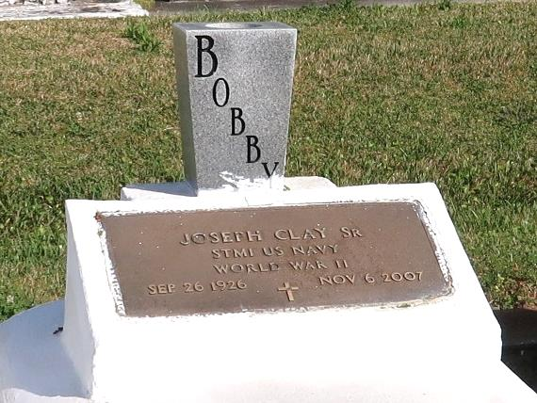

CLAY Joseph (Bobby) Clay, Sr. passed away on Tuesday, November 6, 2007. He was 81 yars. old. A native of Wallace, La. and a resident of New Orleans, La. for 54 yrs. prior to his return to Wallace after Hurricane Katrina. Beloved husband of Mary Helen Adams Clay. Loving father of Joseph (Skizer) Clay, Jr. (Ora Magee Clay), Pamela Clay Williams and the late Tyrone Dominic Clay. Also survived by 5 grandchildren, 4 great grandchildren, 2 sisters, 2 brothers, 3 godchildren, and a host of nieces, nephews, cousins, other relatives and friends.

Relatives and friends of the family; also priest and parishoners of St. David's and St. Phillip Catholic Churches; members of the Knights of Peter Claver Father John Daly Council #125; employees of the former Celotex Corp., Orleans Parish School Board, New Orleans Longshoreman Assoc., and the City of New Orleans are invited to attend a Mass of Christian Burial on Satuarday. November, 10, 2007 at 10:00am from the St. Phillip Catholic Church, 1175 La. Hwy. 18 (River Road), Vacherie, La. Father Louis Oubre - celebrant. Visitation at the church after 8:00am on Saturday. Interment Church Cemetery. The Baloney Funeral Home LLC 399 Earl Baloney Dr. Garyville, La. 70051 Information: (985) 535-2540 In charge of arrangements

Published by The Times-Picayune (LA) on Nov. 9, 2007.