Eola (Scioneaux) Dorest

September 14, 1916 – August 14, 2015

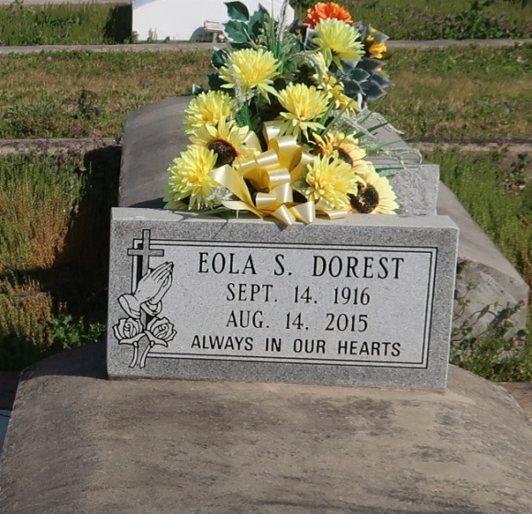

Eola "Mom" Scioneaux Dorest entered into eternal glory on Friday, August 14, 2015 in Wallace, Louisiana at the age of 98. Daughter of the late Aristead and Laura Joseph Scioneaux. Beloved wife of the late Norvin Dorest. Devoted mother of Vernita Adams and Georgiana Jack and the late Paul Dorest. Loving grandmother of Karen Monroe, Tracey McNeal, Rhea Jack, Kima Evans, and Tiffany Roussell. Great-grandmother of Max, Elias, and Theo Monroe; Braelen, Brehyn, and Brandeis Evans, and Evan Roussell. Sister-in-law of Helen Mullen. Also survived by a host of nieces, nephews, cousins, and friends. She is preceded in death by 13 siblings, a daughter in law Ammie Dorest, sons in law Lawrence Adams, Joseph Jack, and godchild Nellie Ester.

Relatives and friends of the family and pastors and members of all neighboring churches are invited to attend her Celebration of Life Services at Morning Star Missionary Baptist Church, 5355 Louisiana Highway 18, Wallace, LA on Saturday, August 22, 2015 at 11:00 AM. Rev. Frank Johnson, Officiating minister. Visitation will begin at 9:00 AM on Sat. There will be a gathering of family, food and friends at Treasures of Life Center for Life Funeral Services, from 4-6pm, Friday August 21, 2015. Interment: St. Phillip Catholic Church Cemetery, Vacherie, La. Services entrusted to Treasures of Life Center for Life Funeral Services, 315 E. Airline Hwy., Gramercy, La. 225-258-4039.

Published by The New Orleans Advocate from Aug. 20 to Aug. 22, 2015.