Ada Elizabeth (LeBoeuf) Dufresne
January 30, 1897 – June 2, 1997

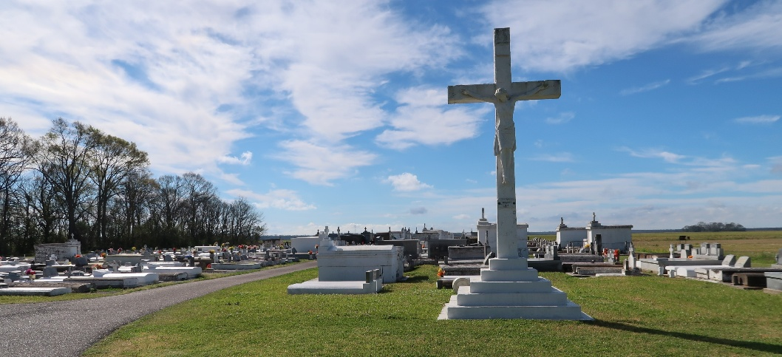

Ada Elizabeth Dufresne on Monday, June 2, 1997, at 1:00 o’clock PM. Beloved wife of the late Jean Severin Dufresne. Mother of May Robertson, Winnie McCormick, Pearl Gallodoro, Dolores Boren, and the late Annette Dufresne, Antoinetta Durand, Roy and Lester Dufresne. Daughter of the late Effie Blouin and Theophile LeBouef. Also survived by 27 grandchildren, 61 great grandchildren, and 9 great great grandchildren, age 100 years, a native of Convent, LA and a resident of New Orleans for the past 66 years.

Relatives and friends of the family are invited to attend funeral services at Mothe Funeral Homes, Inc., 2100 Westbank Expressway, Harvey, LA on Wednesday, June 4, 1997, at 9:30 o’clock AM. A Funeral Mass will be celebrated at Infant Jesus of Prague Catholic Church, Harvey, LA at 9:45 AM. Interment St. Phillip Cemetery, Vacherie, LA at 12:00 noon. Parlors will be open Wednesday, June 4, 1997 from 8:00 AM until 9:30 AM. Masses preferred in lieu of flowers.

Unknown newspaper clipping

