George P. Faucheux
November 15, 1936 - August 15, 2024

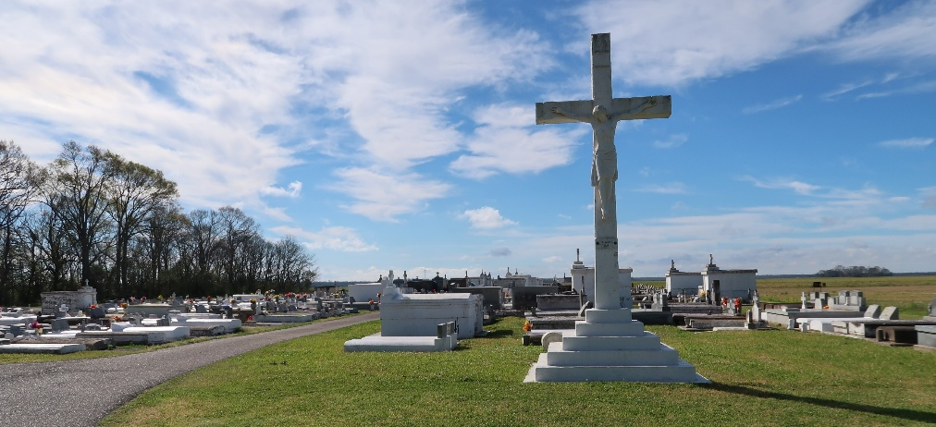

George P. Faucheux passed away on Thursday, August 15, 2024 at the age of 87.
Beloved husband of Louise Tassin Faucheux for 59 years. Loving father of Louise Lapeyrouse (Chester), Margaret Landry (Shane) and George Faucheux, Jr. (Michelle). Grandpa of Quentin Lapeyrouse, Kaitlyn Lapeyrouse, Remington Landry (Janie), Hannah Landry, Emily Faucheux and Tyler Faucheux. Great Grandpa of Elle and Natalie. Son of the late Martha Haas Faucheux and Ferducie Faucheux.
Relatives and friends are invited to attend the Visitation and Memorial Mass at St. Philip Catholic Church, 1175 LA-18, Vacherie, LA on Tuesday, August 20, 2024. Visitation at the church from 9:00 a.m. to 11:00 a.m. followed by a Memorial Mass at 11:00 a.m. Interment in St. Philip Cemetery, Vacherie, LA.

Rose Lynn Funeral Home, Gramercy, Louisiana
August 16, 2024

