Lucien Gerard Faucheux

August 7, 1926 – August 19, 2004

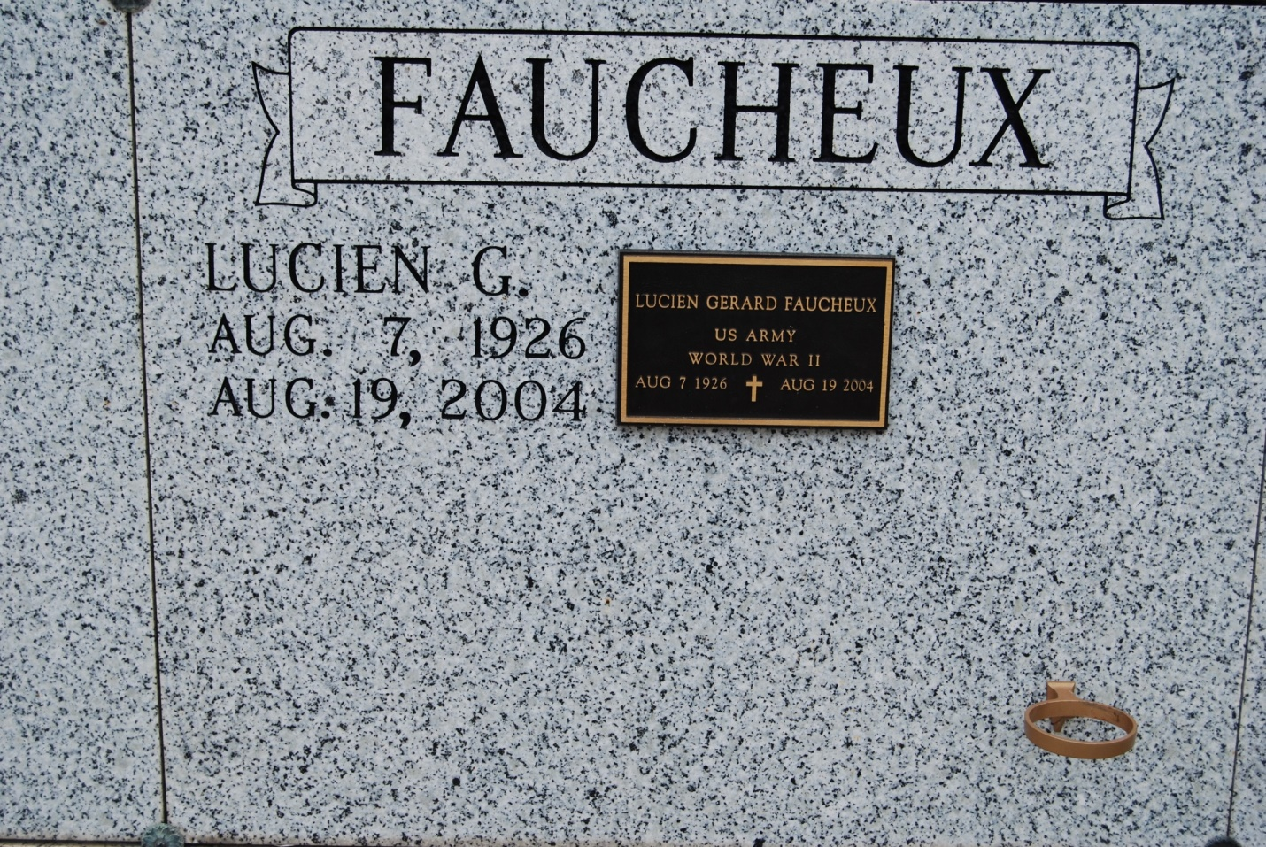

Photo by Kerry Keller

Lucien Gerard Faucheux, a retired lab worker for Colonial Sugar, died Thursday of cancer at his home. He was 78. Mr. Faucheux was born in Wallace and lived in Vacherie. Survivors include his wife, Joyce Waguespack Faucheux; two daughters, Brenda Faucheux and Diane Champagne; three sons, Donald, Charles and Mark Faucheux; five sisters, Enola, Malvin and Lynn Faucheux, Mable Cazenave and Vivian Waguespack; three brothers, Lewis, Clarence and Clifford Faucheux; seven grandchildren; and two great-grandchildren. A Mass will be said Saturday at 10 a.m. at St. Philip Catholic Church on River Road in Vacherie. Visitation will be today from 6 to 9 p.m. at H.C. Alexander Funeral Home, 2208 Jefferson Highway, Lutcher, and on Saturday at 8 a.m. at the church. Burial will be in the church mausoleum.

Times-Picayune, The (New Orleans, LA) - Friday, August 20, 2004