Antoine Favorite

June 16, 1920 – May 27, 2005

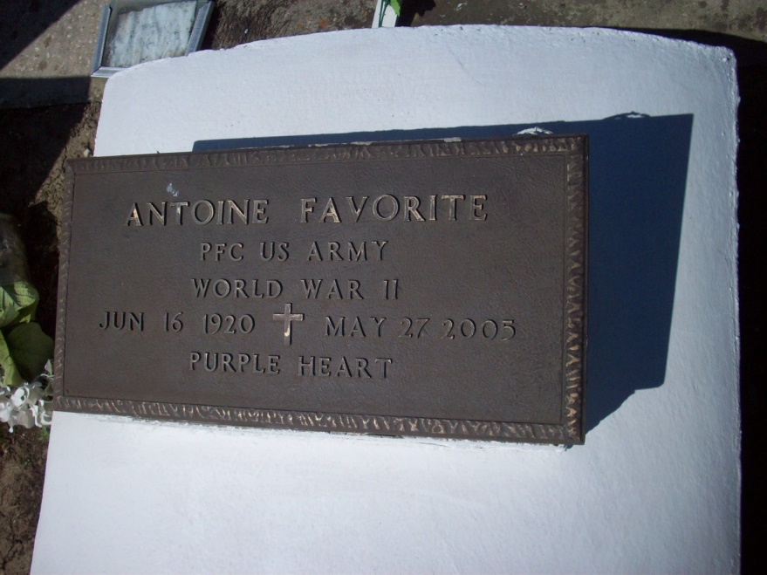

Photo by TMB

Antoine "Dime" Favorite, of New Orleans, LA, passed on Friday, May 27, 2005 at St. Martin Manor. Survived by: one son, Harold Favorite; one sister, Louise Schexnayder; two grandchildren: Antoinette and Jeffery; and a host of nieces, nephews, cousins and friends. A native of Vacherie, LA and a resident of New Orleans, LA. Age 84 years.

Unknown source

\*\*\*\*\*

VACHERIE - Antoine "Dime" Favorite, 84, a native of Vacherie and resident of New Orleans, died May 27. He was the father Harold Favorite. He is survived by his sister Louise Schexnayder. He is also survived by two grandchildren Antoinette and Jeffery. Services and interment were held May 30 at the St. Philip Catholic Church Cemetery, Vacherie.

L'Observateur (La Place, LA)

Monday, June 6, 2005