Leopold Louis Gravois

July 20, 1903 – December 31, 1980

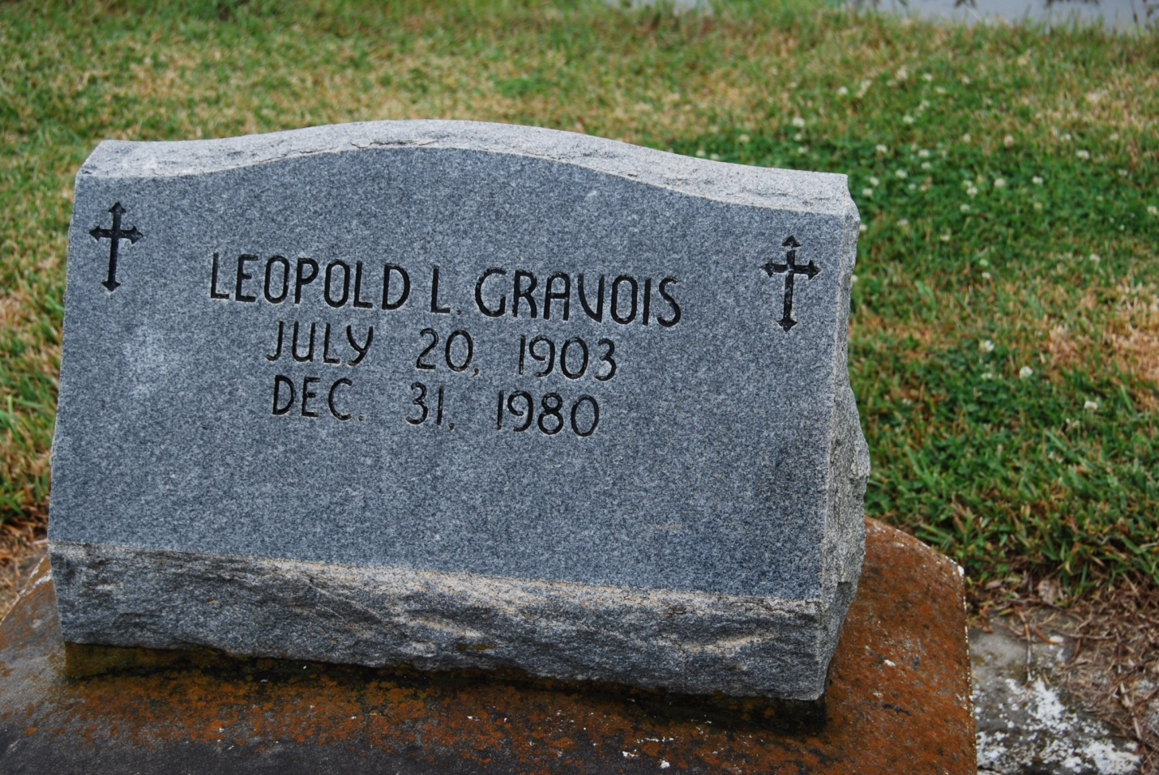

Photo by Kerry Keller

Leopold Louis Gravois, 77, Roseland Nursing Home, Massillon, died Wednesday at Massillon Community Hospital following a one-year illness. Services at St. Phillip's Catholic Church with burial at the church cemetery, Alexander Funeral Home is handling arrangements. Monbarren Funeral Home in Dalton local arrangements. For several years he prepared income tax forms. Member of St. Agnes Catholic church of Orrville, the National Society of Public Accountants and Knights of Columbus of New Orleans.

Surviving one daughter, Mrs. Tom (Barbara) Peters; two grandsons; seven brothers, Henry J., Claude T., Gaston J., Ernest B., Theodore L., Wilfred J. and Edgar, two sisters, Mrs. Leonard (Maud) Waguespack and Mrs. Ozane (T Rose Marie) Abadie Sr. Two brothers and two sisters died previously.

The Daily Record

January 2, 1981

Contributed by [Beverly Sprowl](https://www.findagrave.com/user/profile/22571442)