John Grow Sr.

November 19, 1927 – June 4, 2001

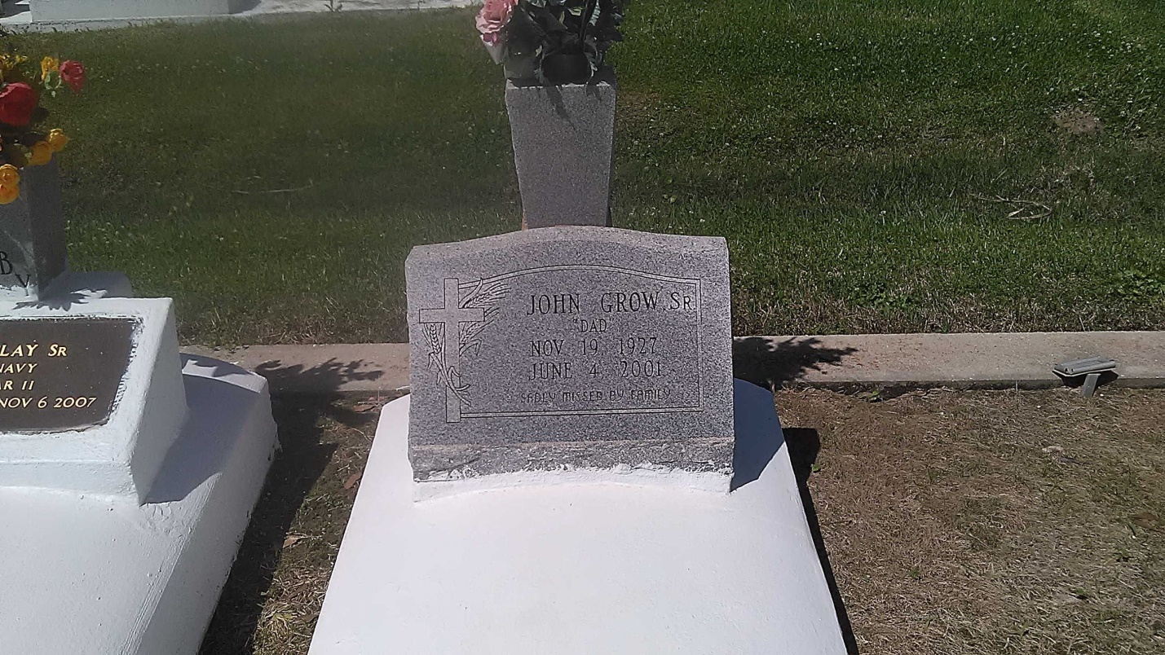

Photo by TMB

GROW VACHERIE - John "Dad" Grow Sr., 73, a native of Vacherie and resident of Wallace, died June 4. He was the husband of Florida Clay Grow and father of Elizabeth Rousseve, Valerie Johnson and Thomas and John Grow Jr. He was also the son of the late Aurelien and Augustine Grow and brother of Bernadine Bartholomew, Pearl Clark and Pierre, George, Aurelien and Lazin Grow. He is also survived by nine grandchildren. He was a retired farmhand. Services were June 8 at St. Philip Catholic Church, Vacherie, with interment at the church cemetery.

L'Observateur (La Place, LA) - Saturday, June 9, 2001