Margaret (Joseph) Grow

November 22, 1926 – September 9, 2012

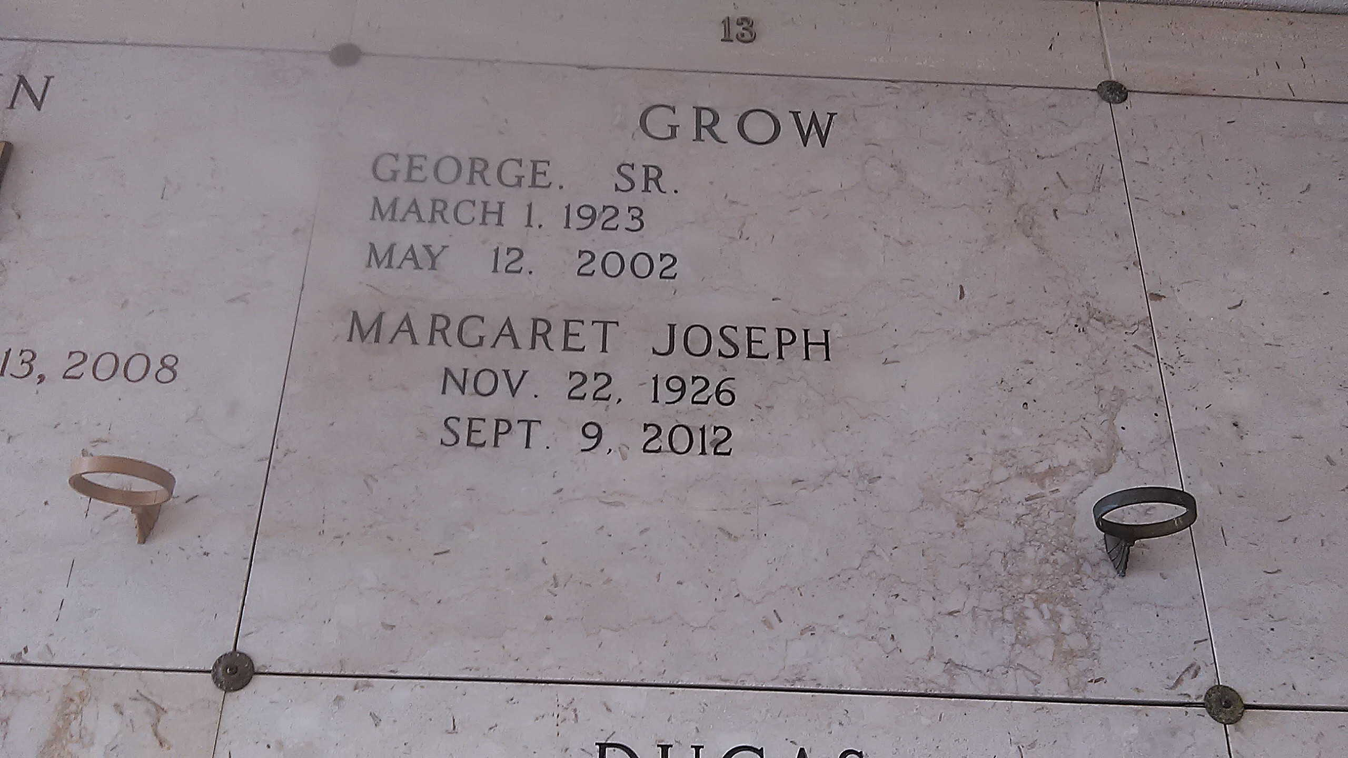

Photo by TMB

Margaret Joseph Grow of Wallace, La. passed away on Sunday, September 9, 2012 at the age of 85 at her residence with her family at her bedside. She was the beloved wife of the late George Grow Sr., daughter of the late Wilson and Albertha Jeffery Joseph. Beloved mother of Hamilton Growe, Sheila Grow Baloney (late Earl Jr.) and the late George Grow Jr. Grandmother of Brandi M. Growe, Courtney G. Baloney and Heather Growe Nelson (Shawn). Great grandmother of Lauryn Baloney and Shawn Nelson Jr. Sister of Pecola Growe and the late Elsie, Jeffery, Frank, Raymond, Aronld, Joe Joseph, Cecile Wilson and Beatrice Pollard. Mother in law of Elitha A. Growe and Marie B. Grow. Survived by a host of sisters and brothers-in-law, nieces, nephews, cousins and other relatives and friends. Devoted caregivers, Doris Frazier and A. Jean Becnel.

Relatives and friends of the family, also priest and parishoners of St. Phillip Catholic Church, Our Lady of Grace Catholic Church and neighboring churches, mebers of Knight & Ladies Auxillary of St. Peter Claver, employees of St. John Parish School Board and Dow Chemical are all invited to attend a mass of Christian burial on Thursday, September 13, 2012 at 11:00am at St. Phillip Catholic Church, 11175 Hwy 18, Vacherie, LA with Father Chris Decker as celebrant. Visitation at 9:00am, recitation of the Rosary at 9:30am. Entombment, church mausoleum. Arrangements by Heritage Funeral Directors (504) 944-5500. Courtney Baloney, funeral director.

Times-Picayune, The (New Orleans, LA) - Wednesday, September 12, 2012