Pierre Phillip Grow

May 27, 1921 – June 19, 2007

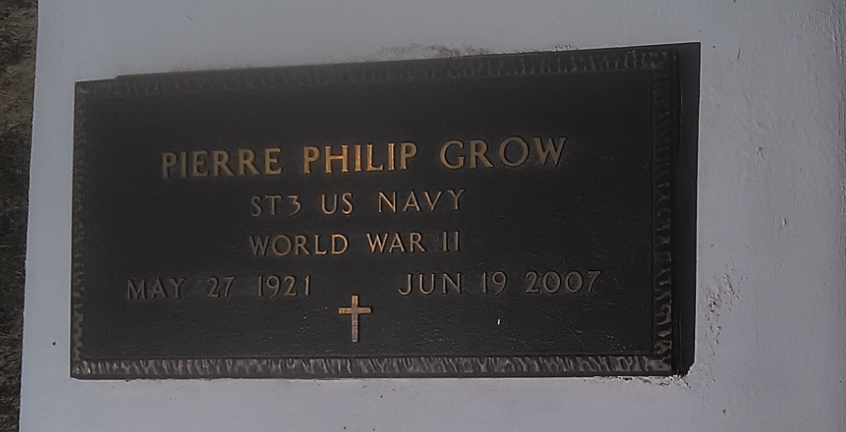

Photo by TMB

Pierre (Red) Grow of Vacherie, LA at Covenant Nursing Home, New Orleans, LA on June 19, 2007. Former husband of Gladys Jefferson Grow. Brother of Bernadine Bartholomew of Vacherie and Pearl Clark of New Orleans, and the late George Grow, Sr., Aurelian "Zan" Grow, John Grow, Sr. and Lazin Grow, Sr. Devoted uncle of Shelia G. Baloney and Sandy B. Warren. Nursing home roommate for many years, Cyril "Sonny" Gonzales. Also survived by a host of sisters-in-law, other nieces, nephews, cousins and friends. A native of Vacherie, LA and a resident of New Orleans for many years. Pierre was active and energetic in his younger days that enjoyed playing cards and horse racing. He was an active member of the Autocrat Club.

Relatives and friends of the family, also Priest and parishioners of St. Phillip Catholic Church, Vacherie, LA, are invited to attend a Mass of Christian Burial on Saturday, June 23, 2007 at 11:00 AM from the St. Phillip Catholic Church, Vacherie, LA. Father Louis Oubre, Celebrant. Interment church cemetery. Visitation at the church after 8:00 AM. The family would like to thank the staff of Covenant Nursing Home, Concerned Care Hospice and Dr. David Meyers.  
 The Baloney Funeral Home L.L.C., 399 Earl Baloney Dr., Garyville, LA 70051, (985) 535-2540. In charge of arrangements.

Times-Picayune, The (New Orleans, LA) - Friday, June 22, 2007