Ann Haas
January 24, 1969 - December 25, 2025

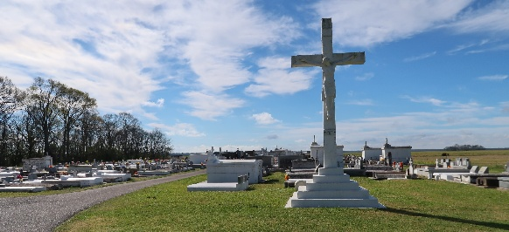

Ann Haas, a native of Vacherie, LA and a resident of River Ridge, LA, passed away on Thursday, December 25, 2025 at the age of 56.
Loving companion of Ed Gianelloni for over 6 years. Beloved dog mom of Sparky, a rescue poodle. Daughter of George Haas and Nancy Becnel Haas. Sister of JoAnn Waguespack (Kim) and Judy McLain (the late Tom). Aunt of Jared Waguespack, Josh Waguespack (Jamie), and Richie McLain. Great Aunt of Landon Waguespack, Emma Waguespack, Logan Waguespack and Kase Waguespack. She was preceded in death by her grandparents Pierre & Delphine Haas and Curtis & Eugenie Becnel.
Ann graduated from Nicholls State University with a Bachelor’s Degree in Nursing. Most of her nursing career was at Ochsner Main Campus in Jefferson, LA. She was selected as the Ochsner Surgical/Procedural Nurse of the Year in 2025, as well as a Daisy award honoree for true compassion in a time of need. She was also previously selected as a Top 100 Nurse in Louisiana.
Ann was a dedicated nurse, fun loving individual, knew all the best restaurants, excellent pastry chef and enthusiastic shopper.
Relatives and friends are invited to attend the Memorial Visitation and Memorial Mass at St. Philip Church in Vacherie, on Saturday, January 3, 2026. Visitation will be from 9:30 am - 11:00 am with the Memorial Mass beginning at 11:00 am. Burial will follow the services at St. Philip Catholic Cemetery.

Rose Lawn Funeral Home, Lutcher, Louisiana
December 30, 2025

