Aline (Borne) Hymel

September 24, 1926 – December 18, 2015

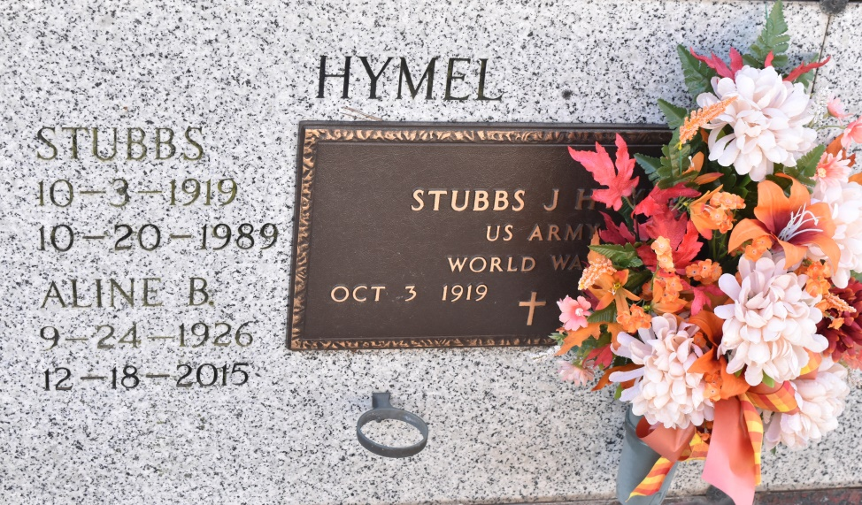

Aline B. Hymel, age 89, passed away on December 18, 2015. She was a Native of Wallace, LA and a resident of Vacherie, LA. She is survived by her sisters: Maisy Cazenave and husband E.V., Anne Hymel, and sister-in-law, Mary Ann Borne. She was preceded in death by her husband, Stubbs Hymel; parents Elise Tassin Borne and Sidney Borne; a sister, Winnie Aubert and husband Francois; a brother, Clifford Borne and a brother-in-law, George Hymel.

Visitation will be on Monday, December 21, 2015 from 9:00 a.m. until 11:00 a.m. at St. Philip Catholic Church in Vacherie, LA followed by a Mass of Christian Burial at 11:00 a.m. Burial will be in the church cemetery. ROSE LYNN FUNERAL SERVICES is in charge of the arrangements. To sign and view the family guestbook, please visit [www.roselynnfuneralhome.com](http://www.roselynnfuneralhome.com/)

Published by The Times-Picayune (LA) from Dec. 19 to Dec. 21, 2015.