Harry Joseph Hymel
January 9, 1929 - July 3, 2025

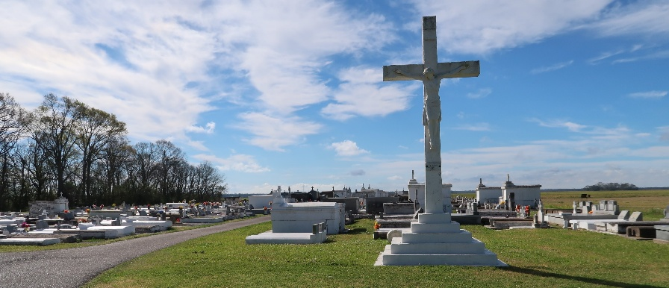

Harry J. Hymel passed away on July 3, 2025, at the age of 96. He was born on January 9, 1929, and was a lifelong resident and native of Vacherie, LA.
Harry is survived by his wife of 72 years, Emeranthe Weber Hymel; his daughter Patricia Becnel (Randy); his sons, Stephen Hymel (Missy) and Gary Hymel (Lori); five grandchildren: Jennifer Rome (Brian); Ryan Becnel (Beth), Jordan Hymel (Tyler), Jared Hymel (Laney), and Rylee Hymel; and four great grandchildren: Kaylee Rome, Layla, Edith and Royce Becnel. He is also survived by his two sisters, Ethel Recatto and Judy Waguespack, and one brother, Lynn Hymel.
He was preceded in death by his parents Albon Hymel Sr. and Fidelise Amedee Hymel; one son Carl Hymel; brothers Burchman, Albon Jr., Jerome, and Kenneth Hymel; and sisters Hazel Rome, Merilyn Kliebert and Virgie Waguespack.
Harry served as an usher at St. Philip Catholic Church, was a Charter member of the Vacherie Volunteer Fire Department and was a 10-year Veteran of the Louisiana National Guard. He loved helping others and had a passion for accounting. He was well known for being the manager of the BW Clothing Store and then later worked at First American Bank in Vacherie.
The family would like to thank his dedicated caregivers and Haydel Hospice for their exceptional service.
A visitation in his honor will be held on Thursday, July 10, 2025, at St. Philip Catholic Church 1175 LA-18 Vacherie, LA 70090 from 8:30 until service time. A Mass of Christian Burial will begin at 11:00 am at St. Philip with Rev. Mike O’Rourke officiating, with a burial following in the St. Philip Mausoleum. Pallbearers will be Randy Becnel, Ryan Becnel, Jared Hymel, Tyler Holder, Donald Nash and Brian Rome.

Rose Lynn Funeral Home, Lutcher, Louisiana
July 9, 2025

