Clarence Jackson Jr.

June 30, 1974 – April 2, 2020

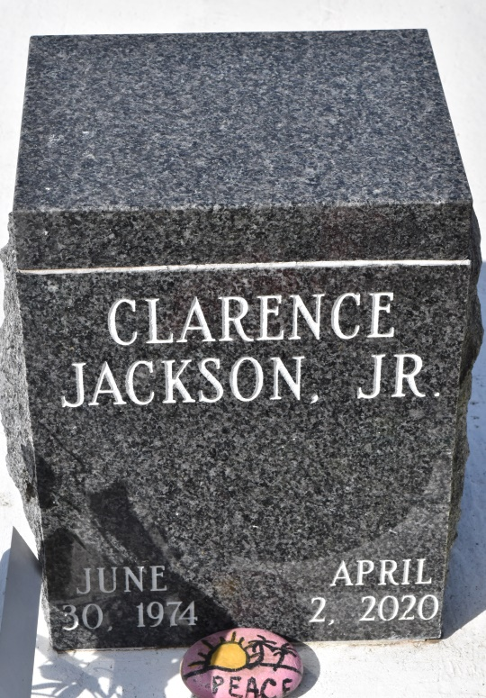

Clarence Jackson Jr. aka “June" and "Lil Sim”, age 45 of Baton Rouge/Wallace passed away on April 2nd at Our Lady of the Lake Hospital. June was born in New Orleans to Leslie Adams Griffin and Clarence Jackson Sr.  
 June graduated from West Saint John High Class of 93. He enjoyed the simpler things in life like hanging out with family and friends, grilling, boiling, cards and dominoes. Lil Sim was an overall good guy with a huge heart willing to help anyone he could.  
 He is survived by his parents Leslie (the late Eddie Griffin) and Clarence Sr. (Marilyn), children Cory Jackson, TyBracia Gibson and Ken-Lysia Washington, siblings Michele Barre (Titus), Dashana Jackson, Demond Jackson, Derrick Washington, Chad Washington, Jeremy Jackson, and a host of aunts, uncles, nieces, nephews, cousins, other relatives and friends.  
 June will always be remembered as a loving son, brother, father & friend.

Treasure of Life Funeral Services, Gramercy, Louisiana