Willie Jasmin
May 25, 1916 - December 23, 2000

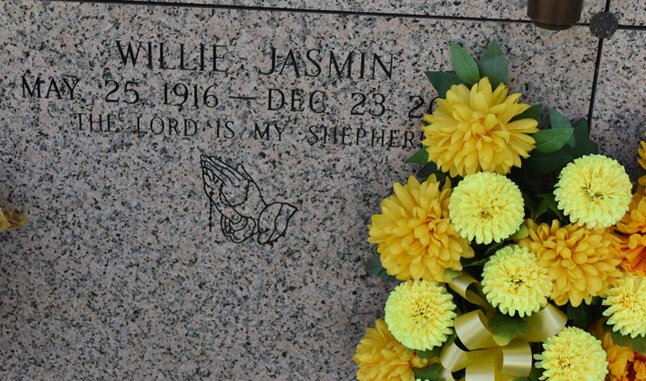
Willie was born on May 25, 1916 and passed away on Saturday, December 23, 2000. Willie was a resident of Vacherie, Louisiana. Willie Jasmin of Vacherie died Dec. 23, 2000. He was the husband of Doretha Adams Jasmin and father of Carrie Lee Borne, Brenda Dumas and Cheryl Williams, Jerome Norwood Adams and the late Willis, Marvin and Johnny Jasmin. He was the brother of August Jasmin, Almeria Heard and Geraldine White. He is also survived by 21 grandchildren and 14 great-grandchildren. He was preceded in death by his parents, Clothilde and August Jasmin, four sisters and four brothers. Services are today at 11 a.m. at the First Baptist Church, Vacherie. Interment will be at the St. Phillip Catholic Church Mausoleum, Vacherie. Visitation at the church begins after 8:30 a.m.
Unknown source
Contributed by Team T Lo
**

JASMIN VACHERIE – Willie Jasmin of Vacherie died Dec. 23. He was the husband of Doretha Adams Jasmin and father of Carrie Lee Borne, Brenda Dumas and Cheryl Williams, Jerome Norwood Adams and the late Willis, Marvin and Johnny Jasmin. He was the brother of August Jasmin, Almeria Heard and Geraldine White. He is also survived by 21 grandchildren and 14 great-grandchildren. He was preceded in death by his parents, Clothilde and August Jasmin, four sisters and four brothers. Services are today at 11 a.m. at the First Baptist Church, Vacherie. Interment will be at the St. Phillip Catholic Church Mausoleum, Vacherie. Visitation at the c…

L’Observateur, LaPlace, Louisiana
Wednesday, December 27, 2000

