Jeremy Jenkins

April 18, 1977 – February 5, 2017

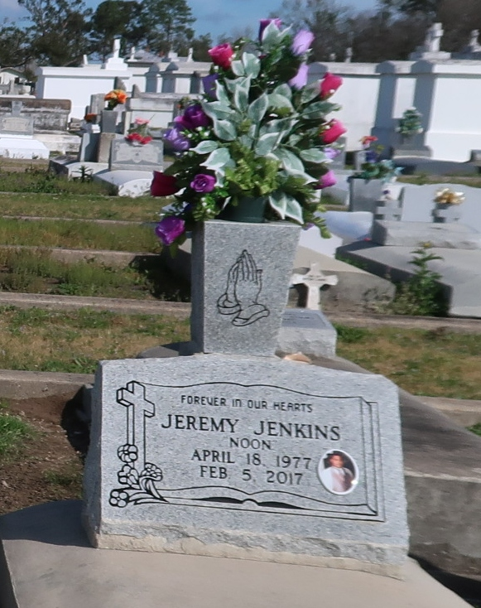

Jeremy "Noon" Jenkins, departed this life on Sunday, February 5, 2017 at the age of 39; Beloved son of Martha Woods and the late Arnold Jenkins; Stepson of Amos Woods; Brother of Dajeunee and Amber Woods; Also survived by 1 nephew, Tyrus Price; 2 nieces, Aurora Price and Kaiya Woods and a host of cousins, other relatives and friends.

Relatives and friends of the family are invited to attend the Funeral Mass of Christian Burial at St. Phillip Catholic Church, 1175 Hwy 18, Vacherie, LA on Monday, February 13, 2017 at 11:00 am; Fr. Matthew McCaughey, celebrant; Recitation of the Rosary will begin at 9:30 am; Visitation will start at 9:00 am; Interment: St. Phillip Catholic Church Cemetery; Arrangements by DW Rhodes Funeral Home, 3933 Washington Ave.; Please visit [www.rhodesfuneral.com](http://www.rhodesfuneral.com/) to sign the guest book.

Published by The Advocate (LA) from Feb. 11 to Feb. 13, 2017.