Whitney Duke Joseph
February 25, 1952 – January 10, 2025

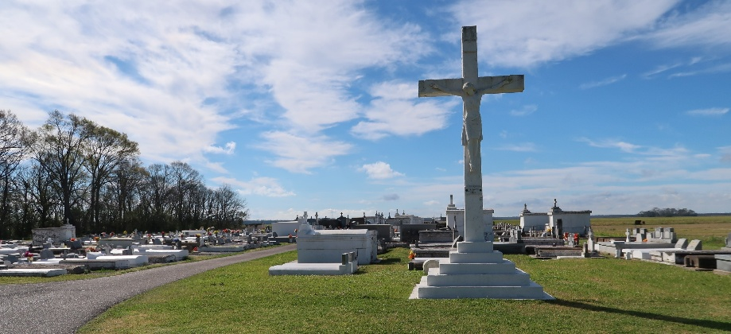

Whitney Duke Joseph was born to Ammize and Douglas Joseph on February 25, 1952. Whitney was called home to glory by an angel from heaven. God said, my son I know that you are weary so I have sent an angel to bring you home. Our beloved brother, uncle, and friend, Dukie, as he was known by everyone, passed away peacefully at Chateau St. James Nursing Facility in Lutcher, LA, on Friday, January 10, 2025. He was a native of Wallace, LA.
Dukie was a graduate of Edgard High School now known as West St. John High School. Dukie was very active in church where his faithfulness led him to serve as the first African American alter server in St. Philip Catholic Church.
Dukie was always a friendly and well known person. In his younger days, his passion was art. He loved building objects out of cardboard boxes often creating replicas of many historical buildings from the area.
Dukie was preceded in death by his parents, Ammize and Douglas Joseph. He now leaves to cherish his memory: his brothers, Frederick (Paulette) Joseph, Morgan (Carol Jean) Joseph, Gerald Joseph, and his only sister, Valerie Cooper. He also leaves to cherish his memory: his godchildren, Adelle Keller and Clifford P. Cooper, Jr. as well as a host of nieces, nephews, and friends.
The family wishes to thank everyone for their prayers, condolences, visits and phone calls. A very special thank you to the staff of Chateau St. James Nursing Facility. A Mass of Christian Burial will be held on Friday, January 17, 2025 at St. Philip Catholic Church, 1175 LA-18, Vacherie, LA 70090 with visitation beginning for 9am and Mass to follow for 11am. Interment to follow at St. Philip Catholic Church Cemetery.

Treasures of Life Funeral Services, Gramercy, Louisiana
January 25, 2025

