Huey Joseph Kliebert Sr.

March 22, 1936 – December 24, 2018

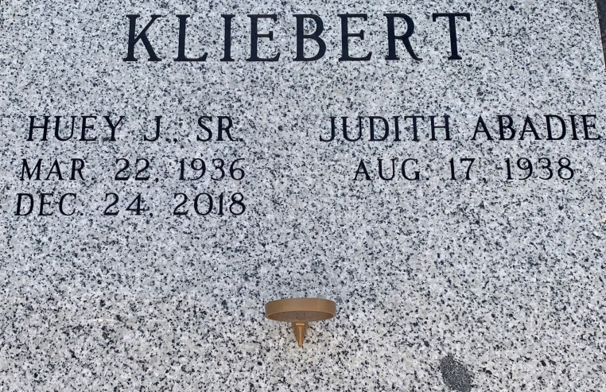

Photo by Team T Lo

Huey Joseph Kliebert, Sr., beloved husband and father, age 82, passed away on December 24, 2018. Huey was born on March 22, 1936 in Vacherie, Louisiana and lived there his entire life.

He is survived by his wife of 60 years, Judith Abadie Kliebert and children, Huey Kliebert, Jr. (Colleen), Nadine Chauvin (Bryan), Cathy Potter, Cindy Zeringue (Craig), Denise Campbell (Colin), Mary Dominique (John), Stephen Kliebert (Lorinda) and Michele Bohnet (Steve); his siblings, Russell Kliebert, Donald Kliebert (Patricia), Gertrude Lasserre (Daniel), Neil Kliebert, Lawrence Kliebert, and Gloria Kliebert; and 19 grandchildren and 6 great-grandchildren.

  He was preceded in death by his parents, Neil and Georgine Oubre Kliebert; his grandson, Philip Kliebert; his siblings and in-laws, Anna Mae and Edmond Dutreix, Patricia Kliebert (wife of Russell), Teresa Perque Kliebert (wife of Neil), and son-in-law Mark Potter.

  Huey worked at Avondale Shipyards for over 40 years and enjoyed spending time with family, hunting, fishing and gardening.

Visitation will be on Friday, December 28, 2018 at St. Philip Catholic Church in Vacherie, La from 8 am to 11 am, followed by a Mass of Christian Burial at 11 am. Interment will occur in the St. Philip Mausoleum.

In lieu of flowers, a donation may be made to the Parkinson’s Foundation, Davis Phinney Foundation, 4730 Table Mesa Drive, Suite J-200, Boulder, CO 80305. Rose Lynn Funeral Services is in charge of the arrangements.  To view or sign the online guestbook, visit [www.roselynnfuneralhome.com](http://www.roselynnfuneralhome.com/).

Rose Lynn Funeral Home, Lutcher, Louisiana