Raymond Gene Landreaux

December 27, 1940 – May 29, 2021

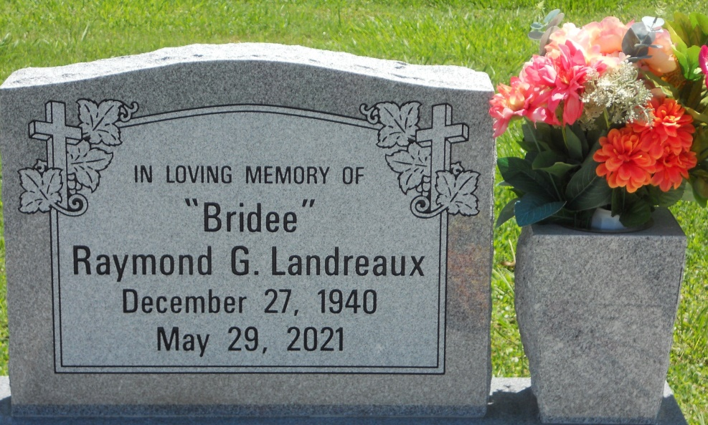

Photo by Team T Lo

On May 29, 2021 at Baton Rouge General with his wife Vera by his side, Raymond Gene (Bridee) Landreaux transitioned from his home of work to a home of eternal rest after a long and faithful journey of 80 years.

Raymond was born December 27, 1940. He was the second oldest of five children born to the union of the late Hillary Sr. and Wilberine Rybiskie Landreaux. He leaves to cherish his precious memories: his devoted wife of 60 years, Vera Mae Paul Landreaux; one sister, Aramenta Christopher; two brothers, Hillary Landreaux, Jr. and Carroll (Catherine) Landreaux; one aunt, Majorie L. Williams; one uncle, Authur B. Landreaux; seven sisters-in-law, Patricia R. Landreaux, Olevia Clark, Hermanese Carter, Wonderlyon Travis, Wanda (Gerard Paul) Simms, Sr., Angela (Michael) Celestine, and Tanya G. Paul; one Godchild, Kelly Booker; and a host of nieces, nephews, cousins and friends.

Raymond Gene Landreaux was preceded in death by his parents, Hillary Sr. and Wilberine Rybiskie Landreaux; brother, Harvell Landreaux; father-in-law and mother-in-law Raymond Jr. & Pasty Mae Pierre Paul; Godchild, Warilyn Rapheal; sister-in-law, Doris Landreaux; and two brothers-in-law Pineal Paul, Sr., and Herman Christopher.

A Mass of Christian burial will be held on Saturday, June 5, 2021, at St. Philip Catholic Church, 1175 Hwy 18, Vacherie, LA 70090. Visitation period will be held from 11am-1pm. Recitation of the Rosary at 12:30pm. Service will begin at 1pm. Interment to follow at St. Philip Catholic Church Cemetery. Final care entrusted to Treasures of Life Funeral Services, 315 E Airline Hwy, Gramercy, LA 70052. 'When someone you love becomes a memory, that memory becomes a Treasure!'. To share condolences and thoughts, and to sign guest book, please visit: [www.treasurefunerals.com](http://www.treasurefunerals.com/). Due to CDC (COVID-19) guidelines and restrictions, masks and social distancing are required!!

Published by The Times-Picayune (LA) from Jun. 3 to Jun. 5, 2021.