Devin Floyd Anthony Louis

March 4, 1987 – October 6, 2004

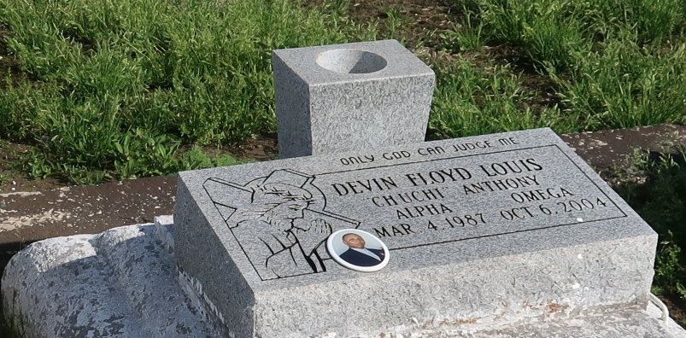

Devin (Chu-Chi) Floyd Anthony Louis, of Wallace, LA. on Wednesday, October 6, 2004. Beloved son of Connie Haydel and Clarence Louis. Brother of Jonas Louis, (Tijeshe), I'desai Louis. Grandson of Theophile and Mercedes (Priscilla) Haydel and James Louis and the late Wilberine Louis. Devoted friend and cousin of Racheal and Ashley Clark. Also survived by a host of aunts, uncles, cousins, friends. Friend of Nicole Washigton. A native and resident of Wallace, LA. Age 17 years.

Relatives and friends of the family, also priest and parishioners of St. Phillip Catholic Church, 2nd African B.C., Our Lady of Grace Catholic Church, St. James Catholic Church, Faculty and Staff of St. James High School, West St. John High School, Remington College, employees of Harmony Cont., Sonic, Frito-Lay, Jefferson Parish Dept. of Juvenille Services, Tomah & Chevron Phillips, are invited to attend a Mass of Christian Burial on Tuesday, October 12, 2004 at 11:00 A.M. from the St. Phillip Catholic Church, Vacherie, LA. Father David Chauvin, celebrant. Interment church cemetery. Visitation at the church after 9:00 A.M. on Tuesday. Recitation of the Rosary at 9:30 A.M. The Baloney Funeral Home 99 Earl Baloney Dr. Garyville, La. 70051(985) 535-2540 In Charge of Arrangements.

Published by The Times-Picayune on Oct. 11, 2004.