Aline (Becnel) Loup
February 14, 1897 – September 11, 1978

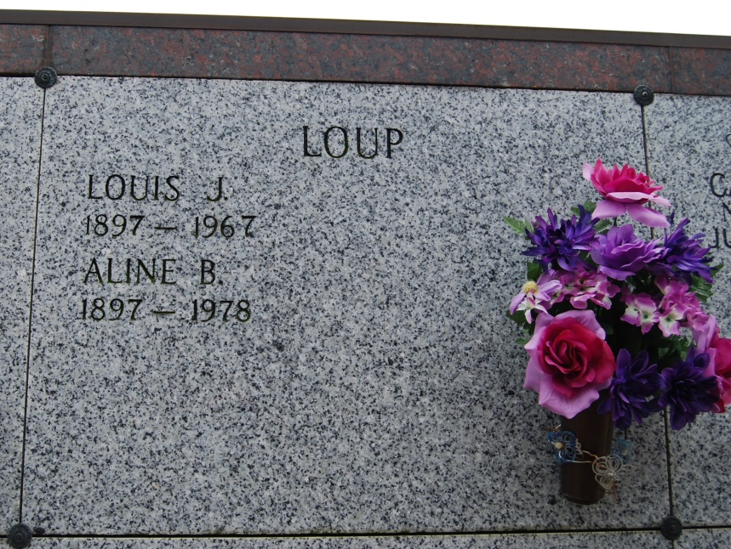
Photo by Kerry Keller

LOUP – Aline Becnel Loup, on Monday September 11, 1979, at 12 o’clock p.m., beloved wife of the late Louis J. Loup, Sr., mother of Roger J. Loup, Andrew G. Loup, Ethel L. Romero, Joyce L. Marks, Iris Ann L. Falgoust, and the late Louis J. Loup, Jr., daughter of the late Amanda Falgoust and Sylvester Becnel; sister of Mrs. Blanche Decarreux, Mrs. C. D. Swarts, Mrs. Lucien Boudreaux, Mrs. Loretta Blagone, Mrs. Marcelitte McCarthy, Ed Becnel Sr., and the late Simon, Peter and Lena Becnel; also survived by 17 grandchildren, and 14 great-grandchildren, age 81 years, a native of Franklin, La., and a resident of Vacherie, La. for 51 years, and a resident of Kenner, La. for the past 7 years.
Relatives and friends of the family are invited to attend the funeral. Services from Leitz-Eagan Funeral Home Chapel, 4747 Veterans Boulevard, near Clearview, on Wednesday, September 13, 1978 at 10 o’clock a.m. Mass in Leitz-Eagan Chapel. Interment St. Philip Cemetery, Vacherie, La. Friends may call after 6 o’clock p.m. Tuesday

Times-Picayune, New Orleans, LA
Tuesday, September 12, 1978, p. 14

