Elia Marie (Zeringue) Loup

October 12, 1876 – September 24, 1964

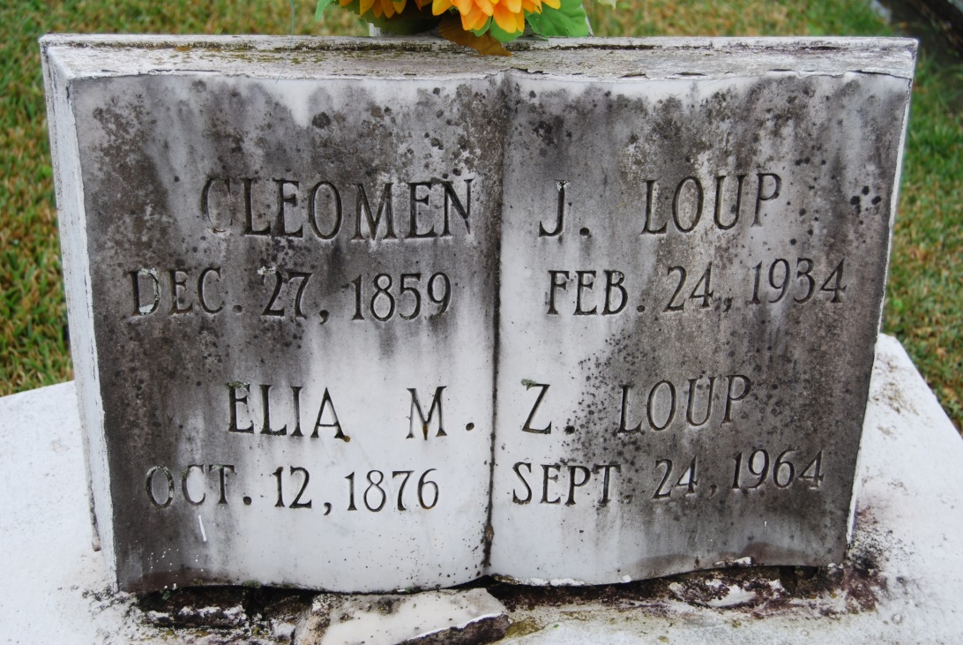

Photo by Kerry Keller

LOUP – On Thursday, September 24, 1964, at 9:30 o’clock p.m., MARIE ELIA ZERINGUE LOUP , WIFE OF THE LATE Cleomen Loup; mother of Louis and Jean Cleoman, and Miss Evelyn Loup, all of Vacherie, La., Maurice A. Loup and Mrs. Louise Breaud, both of Luling, La., Mrs. Stella Theriot of New Orleans, La.; sister of Mrs. Leonia Hymel of Wallace, La., and of the late Mrs. Louisa Schexnayder, Camille, Victorian and Louis Zeringue; also survived by 13 grandchildren and 20 great-grandchildren; age 88 years; a native and a resident of Vacherie, LA.

Relatives and friends of the family are invited to attend the funeral. Services from the The Knights of Columbus Home, Vacherine, La., on Saturday, September 26, 1964, at 9:30 o’clock a.m. Religious services at St. Philip Church, Vacherie, La. Interment in St. Philip Cemetery, Vacherie, La. Arrangements by Alexander Funeral Home, Lutcher, L.

Times-Picayune, New Orleans, LA

Saturday Morning, September 26, 1964, p. 2