Ferdinand Etienne Loup
August 2, 1900 – March 18, 1969

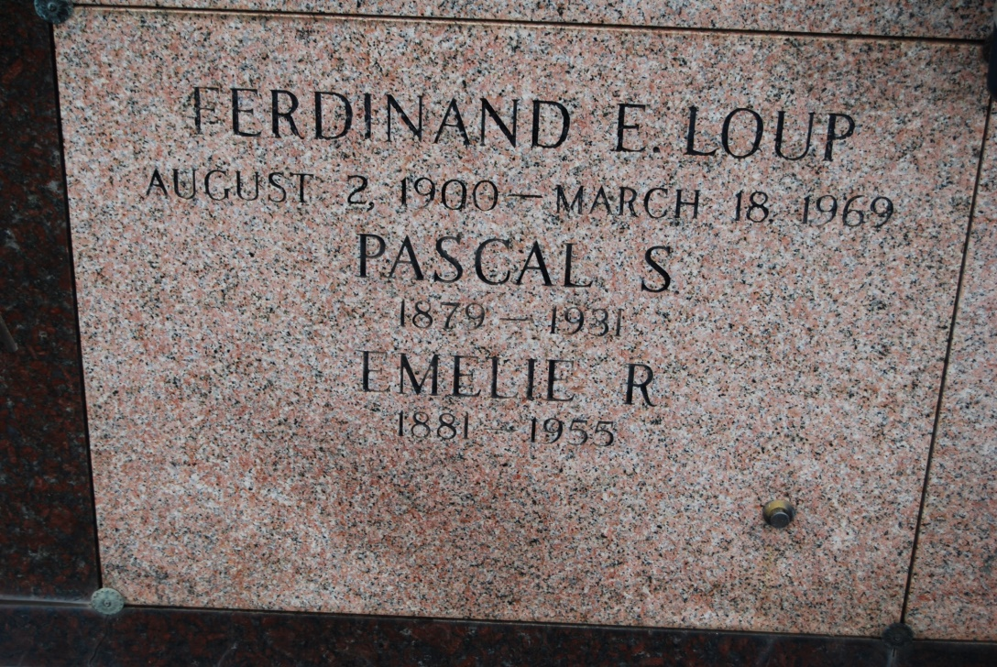
Photo by Kerry Keller

LOUP, FERDINAND ETIENNE – Died at 11:30 a.m. Tuesday at Touro Infirmary in New Orleans. He was 68, a native of St. John Parish and a resident of New Orleans. He was a retired employe of the maintenance department of the city of New Orleans. Body at the Knights of Columbus Home, Vacherie, from 2 p.m. Wednesday until 10:45 a.m. Thursday. Religious services at St. Philip Catholic Church, Vacherie, at 11 a.m., Thursday. Entombment in church mausoleum, by Alexander Funeral Home, Lutcher.
Survived by four sisters, Mrs. Clemence Waguespack and Mrs. Luella Burch, both of Vacherie, Mrs. Lucella Hymel, St. James, and Mrs. Velma Biondello, Baton Rouge; three brothers, Nemour Loup and Felicien Loup, both of Vacherie, and Roy Loup, Sulphur, and a number of nieces and nephews. He was preceded in death by his father Pascal Loup, and his mother, the former Amelie Roussel.

Morning Advocate, Baton Rouge, LA
Wednesday, March 19, 1969, p. 8-A

