Louis Joseph Loup

1897 – December 17, 1967

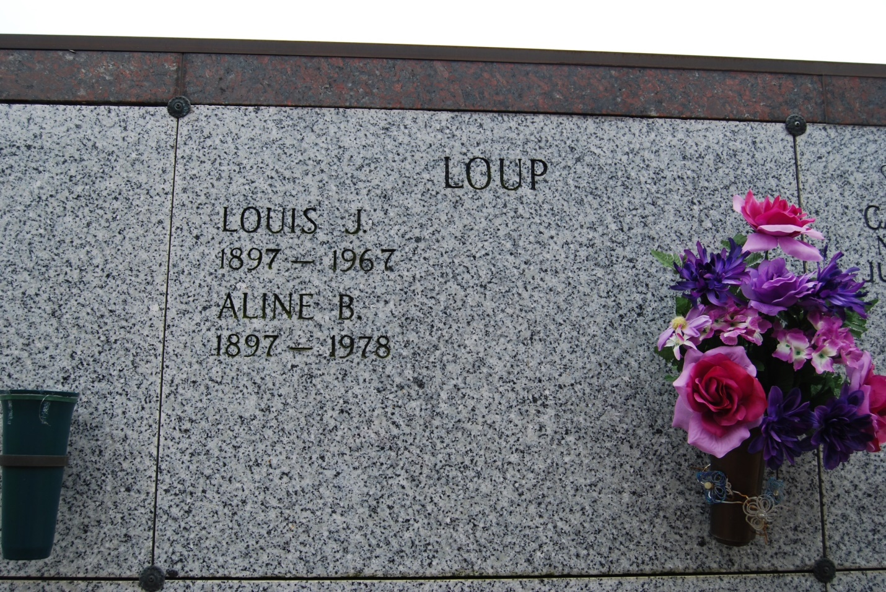

Photo by Kerry Keller

LOUP – On Sunday, December 17, 1967, at 11:05 o’clock p.m., LOUIS JOSEPH LOUP, husband of Eileen Becnel; father of Andrew, Roger, and Louis Loup Jr., Mrs. Ethel Romero, Mrs. Guy Falgout, Mrs. Albert Marks; sone of Clomes Loup, and the late Ella Zeringue. Also survived by 17 grandchildren and one great-grandchild. Age 70 years. A native and a resident of Vacherie, La.

Relatives and friends of the family are invited to attend the funeral. Services from the K.C. Home of Vacherie, La. on Tuesday, December 19, 1967, at 10:00 o’clock a.m. Religious services at St. Philip Catholic church, Vacherie, La. Interment in St. Philip Cemetery. Arrangements by Thibodaux Funeral Home.

Times-Picayune, New Orleans, LA

Tuesday morning, December 19, 1967, p. 8