Claudette Vette Luke

July 20, 1949 – April 14, 2021

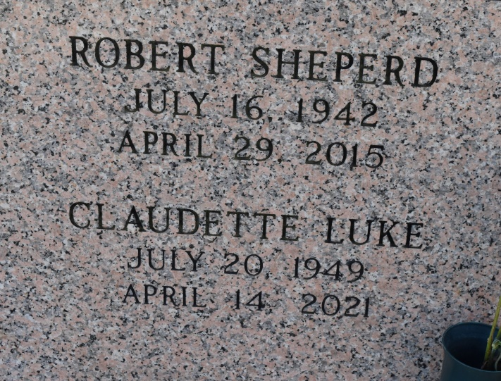

Claudette Vette Luke departed this life on April 14 at the age of 71. She was born to Wilfred Luke, Sr. and Louise Sheperd Luke at Charity Hospital in New Orleans, Louisiana on July 20, 1949, and is the sister of the late Wilfred Luke, Jr., and Robert Sheperd. Raised in Vacherie, she graduated from the historic Holy Rosary Institute in Lafayette. She then went on to attend Southern University in Baton Rouge where she earned a Bachelor's degree in Education. She became an avid educator in the Terrebonne Parish school district for over 30 years, one whose students remember her fondly to this day. A faithful member of St. Philip Catholic Church in Vacherie, she also sang in the St. Philip choir. She was known to enjoy fellowshipping with loved ones, travel cruises, and rooting for her beloved Southern University Jaguars. In the Spring of 2006, she was initiated into Delta Sigma Theta Sorority, Inc., and was subsequently a founding member of the River Parishes Alumnae Chapter in 2013. Claudette was a benevolent and selfless spirit who lived a life of service. Be it through her church, her sorority, or simply her day-to-day interactions, she led with a perpetual kindness and compassion that touched every soul she encountered. Her friends and family not only remember her for her charitable nature, but for her sense of humor, magnanimous personality and infectious laugh.

She is survived by her Aunt Elizabeth Gant, Aunt Dorothy Pollard, niece Treasure Sheperd, godson Jeffery Pollard, and a host of nieces, nephews, other relatives, and friends.

Relatives, friends of the family, priests and parishioners of St. Philip Catholic Church are invited to attend a Mass of Christian Burial on Saturday April 24, 2021 at St. Philip Catholic Church 1175 LA-18 Vacherie, LA at 11:00am. A visitation will be held on Friday April 23, 2021 at Rhodes Funeral Home 3933 Washington Avenue from 5:30 pm until 7:30pm. As mandated by the State of Louisiana due to the COVID-19 pandemic, attendance is limited. Everyone is required to adhere to all restrictions. You must always wear a face mask and practice social distancing. Interment: St. Philip Catholic Church Cemetery, Vacherie, LA. Arrangements by D.W. Rhodes Funeral Home, New Orleans, LA 70125. Please visit [www.RhodesFuneral.com](http://www.rhodesfuneral.com/) to view and sign the online guest book.

Published by The Times-Picayune, New Orleans, LA from Apr. 21 to Apr. 23, 2021.