Marion (Keller) Simon
May 26, 1934 – September 18, 2025

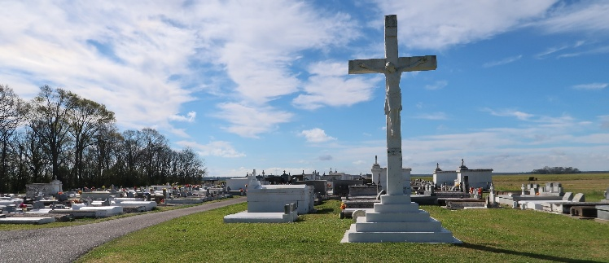

With hearts full of love and gratitude, we celebrate the beautiful life of Marion Keller Simon, born May 26, 1934, to Lucretia Keller and Bernard Keller Sr. Affectionately known as “Lake” and lovingly called “Gram”, she was a cherished soul. In the early hours of September 18, 2025, at the age of 91, God tenderly called her home to eternal life in His heavenly kingdom, where she now rests in perfect peace, embraced by His everlasting love and surrounded by the light of heaven, peacefully surrounded by her beloved family.
Marion was educated in the St. James Parish School System, where she laid the foundation for a life of hard work and dedication. She later entered the workforce as a housekeeper, a role she fulfilled with pride, diligence, and unwavering commitment for many years. Her work ethic and care were reflections of her strong character and deep sense of responsibility.
On July 28, 1956, Marion united in holy matrimony with Dennis Simon Sr. Their marriage was a loving partnership built on faith, commitment, and family, and together they shared a beautiful life and legacy. Marion was a woman of grace, faith, and compassion. A devout Catholic, she was a lifelong member of St. Philip Catholic Church, where her faith served as a foundation and guiding light in her life. She was also a proud member of the Good Children Society, where she found fellowship and joy in serving her community. She brought joy wherever she went, and her love for life was contagious. She especially enjoyed playing bingo, dancing to her favorite tunes with a Dr. Pepper in hand, and trying her luck at the slot machines. More than anything, she loved being surrounded by family and friends—and she never missed an opportunity to show up and celebrate life’s greatest moments with tears of joy. Whether it was a birthday, a graduation, a holiday, or a simple family gathering, Marion’s presence made every occasion feel even more special. Her legacy of love, laughter, and faith will live on in the hearts of those she leaves behind. Though she is no longer with us, we find peace in knowing that she is now resting in the arms of the Lord, reunited with loved ones who went before her.
Marion leaves behind six loving children: Clifford Simon, Cynthia (Bobby Sr.) Johnson, Bonnie Simon, Waynell (Ritchie) Johnson, Dennis Simon Jr. (Phyllis), and Lanracrisse (Sidney) Baptiste. She is also survived by one sister, Carolyn Keller, one brother, Cleveland Keller, and daughter in law Colleen Simon. She is also survived by three sisters-in-law, Velma Florence, Gloria Keller and Ora Lee Borne. Her love and legacy extend to a host of grandchildren, great-grandchildren, nieces, nephews, godchildren, and other family and friends who will continue to carry her memory in their hearts.
Her warm smile, kind heart, and joyful spirit left a lasting impression on all who had the privilege of knowing her. Though she is no longer with us, we find peace in knowing that she is now resting in the arms of the Lord—reunited with her beloved husband, Dennis Simon Sr.; her son, Roger Simon; her mother, Lucretia Keller; her father, Bernard Keller; her siblings, Bernard Jr., Ronald, Raymond, and Annalee Washington; her father-in-law, William Simon; her mother-in-law, Sedonia Simon; her sisters-in-law, Wilbrine Simon, Chlothilde Haydel, and Aldonia Harry; her brothers-in-law, William, Jessie, Ralph, and Joseph Simon; and her dear daughter-in-law, Valerie Simon. She will be deeply missed and forever remembered.
A Mass of Christian Burial will be held on Saturday, September 27, 2025 at St. Philip Catholic Church, 1175 Hwy. 18, Vacherie, LA 70090; visitation beginning for 8:30am followed by Mass for 10:30am. Interment St. Philip Catholic Church.

Treasures of Life Funeral Services, Gramercy, Louisiana
October 2, 2025

