Roger Phillip Simon
July 30, 1958 - July 5, 2025

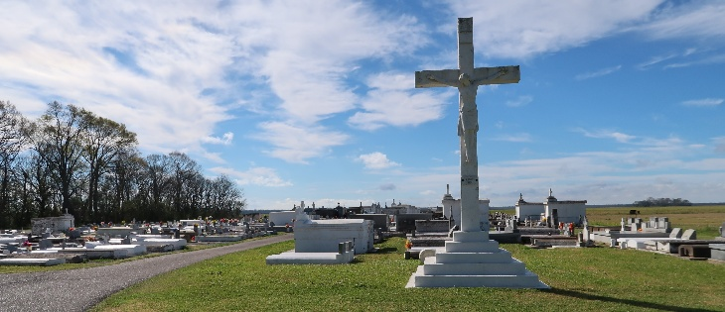

Roger Phillip Simon, a beloved native and lifelong resident of Vacherie, Louisiana, entered eternal rest on July 5, 2025, at the age of 66. He was born on July 30, 1958, in New Orleans, Louisiana, to Marion Simon and the late Dennis Simon Sr. Roger accepted Christ at an early age and was baptized into the Catholic faith at St. Philip Catholic Church in Vacherie, LA. He lived a life rooted in faith, kindness, and compassion. Roger was a devoted father, son, brother, uncle, and friend. He found joy in life’s simple pleasures—fishing, cruising around town, and listening to music, especially his favorite artist, Lil Boosie. Above all, Roger treasured time spent with his family and connecting with others. His warm personality and easygoing spirit made everyone feel welcome, and his genuine presence left a lasting impact on all who knew him. A man of quiet strength and deep faith, Roger was a steady and humble presence in his community. He lived with purpose and touched the lives of many with his wisdom, laughter, and generosity. His legacy of love, joy, and resilience will forever be remembered.
He leaves to cherish his memory: His loving mother, Marion Simon; His wife, Colleen Simon, Six siblings: Bonnie Frazier, Cynthia (Bobby) Johnson, Clifford Simon, Waynell (Ritchie) Johnson, Lanracisse (Sidney) Baptiste, and Dennis (Phyllis) Simon; His children: Mardechria McDonald, Jaruis Charles, Rory Charles, Roger Hamilton, Le Shell Hamilton, Darren Petetant, Rogerelle Simon, and Rogerleah Simon; and Stepkids: Jamal White and Deshawn White. Twenty-two grandchildren; One godchild, Skylar Simon; A host of nieces, nephews, other relatives, and dear friends.
He was preceded in death by his father, Dennis Simon Sr., his grandparents, his uncles, Raymond Keller, Ronald Keller, Bernard Keller, Raph Simon, Jessie Simon, Joe Simon and Williams Simon; his aunts Annielee Washington, Wiberine Chopin, Aldonia Harry and Clothilde Haydel and his sister-in-law, Valerie Simon. Roger's presence may be gone from this earth, but his light and love continue to shine through the many lives he touched.
A Mass of Christian Burial will be held on Saturday, July 12, 2025 at St. Philip Catholic Church,1175 LA-18, Vacherie, LA 70090, for 10:30am with visitation from 8:30am to 10:30am. Interment St. Philip Catholic Church Cemetery.

Treasures of Life Funeral Services, Gramercy, Louisiana
July 13, 2025

