Joseph Steib
October 10, 1952 – May 27, 2025

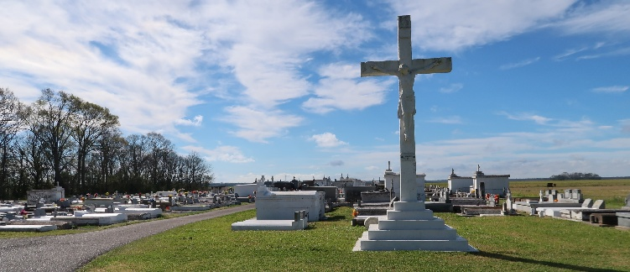

Joseph “Calookie” Steib entered eternal rest on Tuesday, May 27, 2025, at the age of 72, at Jefferson Health Care. He was a native of Wallace, Louisiana, and a longtime resident of River Ridge, Louisiana. Born on October 10, 1952, to the late Joseph Carl Steib and Agnes Armant Sylvester Steib of Vacherie, Louisiana, Joseph was christened and baptized at an early age at St. Philip Catholic Church in Vacherie. He received his education through the St. James Parish School System. Throughout his life, Joseph was known for his strong work ethic and love for the outdoors. He held various positions, including offshore cook, laborer at Ashley Construction and Pacific Railroad, as well as working as a cement finisher and farm hand. His passions included fishing, landscaping, and enjoying nature.
He leaves to cherish his memory his devoted wife of 45 years, Judy Steib of Houma, LA; three children: Carla Joseph and Cina’ Steib of Houma, LA, and Corey Steib of Miami, FL; six grandchildren: Torey and Tyrese Joseph, Giovanni, Onyx, and Emerald Steib of Houma, LA, and Kayleigh Smith of Houston, TX. He is also survived by four siblings: Joann Moll and Deborah Freeman of St. Rose, LA, Bernadette Rainey of Wallace, LA, and Rickie Steib of Vacherie, LA; two uncles: Morris Armant and Charles Armant of Vacherie, LA; three brothers-in-law: Herdle Raphael of Wallace, LA, Douglas Jones of Gray, LA, and Farrow Freeman of St. Rose, LA; one sister-in-law, Trudy Steib of Vacherie, LA; and a host of nieces, nephews, extended family, and friends.
Joseph was preceded in death by his parents, Joseph Carl Steib and Agnes Armant Sylvester Steib; his maternal and paternal grandparents; two sisters: Catherine Mitchell and Diane Raphael; three brothers: Omilece, Hilton, and Antoine Steib; his in-laws, Willie Jones Sr. and Sarah B. Jones; four brothers-in-law: Gregory, Vincent, Bobby, and Curtis Jones; and one sister-in-law, Diane Johnson.
The family of Joseph “Calookie” Steib extends our heartfelt appreciation for the many expressions of love, prayers, and support shown to us during this time of bereavement. A special thank you to Jefferson Health Care and St. Catherine Hospice of River Ridge for their compassionate care.
Celebration of Life A gathering of family and friends will be held on Saturday, June 7, 2025, from 9:00 a.m. to11:00 a.m. at St. Philip Catholic Church, 1175 LA-18, Vacherie, LA 70090. A Mass of Christian Burial will follow for 11:00 a.m. Interment in the church cemetery.

Treasures of Life Funeral Services, Gramercy, Louisiana
May 29, 2025

