Lorraine Marie (Adams) Stewart
Aug. 28, 1937 - Dec. 27, 2025

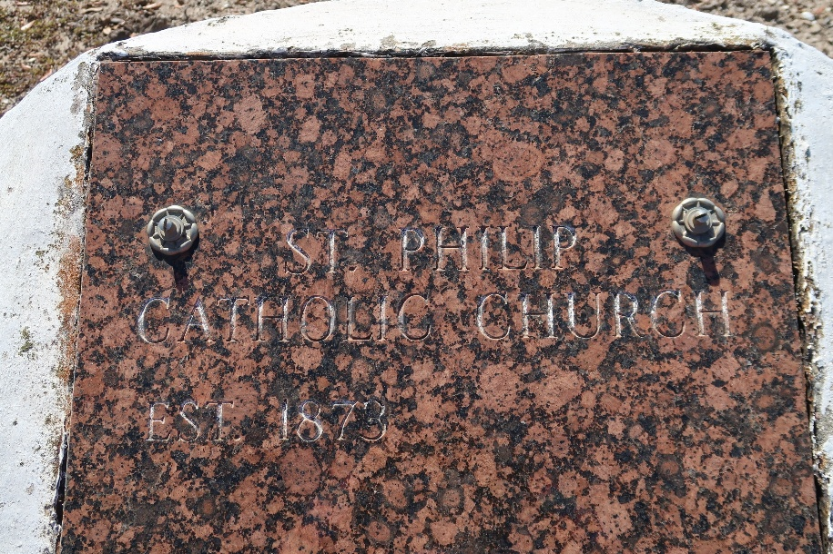

Lorraine Marie Stewart, born on August 28, 1937, in Vacherie, Louisiana, was a woman of extraordinary character. Her life was a radiant testament to the virtues of ambition, compassion, and dedication. Embracing the words of St. Paul, "And whatever you do, in word or deed, do everything in the name of the Lord Jesus, giving thanks to God the Father through him" (Colossians 3:17), Lorraine's life was a living embodiment of her Catholic faith, reflecting both the zeal for service and the love for others that were central to her character.
Lorraine was a master of the culinary arts, whose passion for food nourished the hearts and souls of countless children in the school system. Her dedication saw her through an illustrious career, retiring once from Huddle House at 62 years of age, only to find new purpose at Boutte Christian Academy. Here, she would spend more than 20 years nurturing young minds and palates before retiring a second time. Lorraine's steadfast commitment to her craft was matched by her devotion to her faith. She served as an Extraordinary Minister of Holy Communion and was a respected member of the Ladies of Alter Society.
Lorraine was most alive in the company of her large and loving family. She is survived by her children: Craig Stewart, Sr., Kathy Stewart, Delmus III, Della Markey, Dennis Stewart, Edith Williams, and Kathy Stewart. Lorraine’s legacy lives on in her grandchildren: Delmus IV, Bathsheba Markey, Joevone Claborne, Rychell Williams, Roxanne Green, Keion Ross, April Stewart, Craig Jr., Kolby Ross, and Kody Ross. Lorraine’s love continues to bloom in her greatgrandchildren: Chyanne Stewart, Rachelle Green, Romell Ross, Ava Claborn, Amarie Claborn, Kaleb Stewart, Kaiden Stewart, Katlynne Stewart, Aaliyah Stewart, Alana Stewart, Sean Stewart, Seth Stewart, Craig III, and Raylnn Williams. Lorraine also leaves to cherish her memories several great-greatgrandchildren.
She was preceded in death by her parents, Emile and Althea Adams.
Please join us in celebrating Lorraine's life by sharing your memories and photos on her memorial page. Your stories will serve as a tribute to a woman who committed her life to serving others, both through her culinary talents and her unwavering faith. May her memory be a blessing, and her life an inspiration to us all. A Mass of Christian Burial will be held on Saturday, January 10, 2026 at St. Anthony of Padua, 234 Angus Drive, Luling, LA 70070; visitation 10:00am to 11:00am, followed by Mass for 11:00am. Interment St. Philip Catholic Church, 1175 LA-18, Vacherie, LA 70086. Repast to follow at 313 Boutte Estates Drive, Boutte, LA 70039.

Treasures of Life Funeral Services, Gramercy, Louisiana 70052.
March 17, 2026

