Eunice Ann Wiltz
August 12, 1944 - March 15, 2026

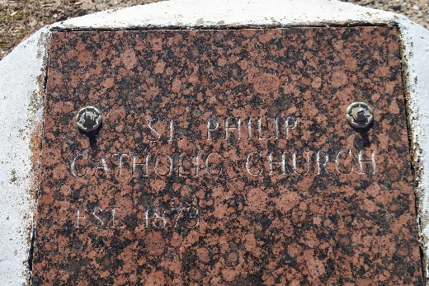

After battling cancer over 14 years, Eunice Ann Wiltz passed away peacefully On March 15th, 2026 at her residence in Baton Rouge, La. Eunice was born on August 12,1944 in New Orleans, La. to the late Adlus Wiltz Sr. and Leboria Clark Wiltz. She was raised in the Catholic faith where she attended St. Philip Catholic Church until relocating to Baton Rouge, La. Eunice was educated in St. John the Baptist Parish School System and graduated from Second Ward High School class of 1965.
Eunice is survived by daughters Valerie Milow and Dinah Wiltz of Baton Rouge, La. One son Wayne Wiltz-Harmon Sr. of Atlanta, Ga. She leaves to cherish her memories, children Valerie Milow, Dinah Wiltz, Wayne Wiltz-Harmon Sr., 10 grandchildren , 5 great-grandchildren, brother-in-law Henry Dumas Sr., son-in-law Eric Domino, 2 godchildren Perry Clark, Deriohlin Charisse Wiltz, and a host of nieces, nephews, friends and relatives.
Eunice is preceded in death by parents Adlus Wiltz Sr. and Leboria C. Wiltz; siblings Ida W. Jackson, Adlus Wiltz Jr., Velma W. Dumas, Doris W. Frazier, Melvin Wiltz, Clinton Wiltz; daughter Bridgette W. Domino, granddaughter Michelle E. Wiltz, grandsons Ramon Domino Sr., and Demarkus Wiltz.
Eunice’s Celebration of Life will be held on Monday, March 30, 2026 at St. Philip Catholic Church, 1175 Hwy 18. Vacherie, La 70090; visitation beginning at 9:00 am followed by the services at 11:00 am. Interment St. Philip Cemetery, Vacherie, La 70090.

Treasures of Life Funeral Services, Gramercy, Louisiana
March 28, 2026

