Gayle Marie (Schexnayder) Zeno
January 18, 1943 - June 22, 2025

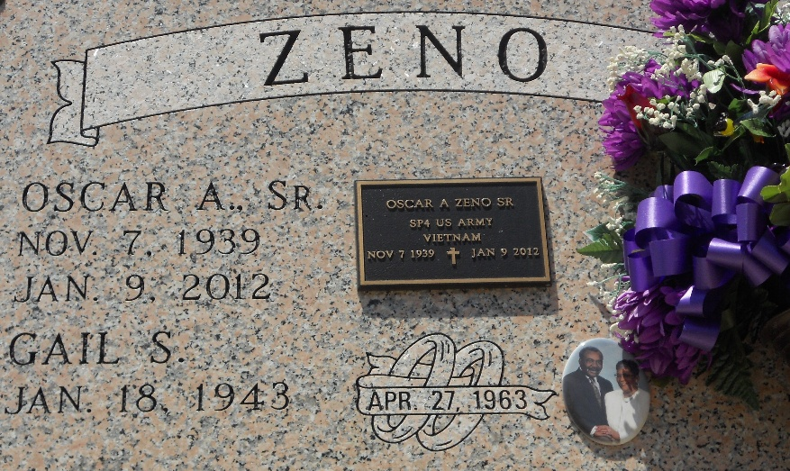
Photo by Team T-Lo

Gayle Marie Schexnayder Zeno, a lifelong resident of Wallace and Vacherie, Louisiana, passed away on June 22, 2025, at the age of 82 surrounded by her children and grandchildren. To those who knew her best, she was simply “Aunt T,” “Mrs. Zeno,” or “Tee.” Gayle was born on January 18, 1943, in Wallace, Louisiana. She was the fifth of nine children born to Guy and Louise Favorite Schexnayder, Sr. Her siblings include Harvey Schexnayder, Guy Eugene Schexnayder Jr., Ruby S. Zenon, Florence Earline S. Jackson, Hardy Schexnayder Sr., Linda S. Carey, and Karl Schexnayder.
She was a devoted Catholic and was christened at St. Philip Catholic Church in Vacherie, Louisiana. Gayle was educated in the St. John the Baptist Parish School System and proudly graduated from Second Ward High School, Class of 1961. Gayle met the love of her life and entered the sacrament of holy matrimony with Oscar A. Zeno, Sr. on April 25, 1963. From this union, they were blessed with two children: Oscar Anthony Zeno, Jr. and Terry Ann Zeno. Gayle raised her children in a strong faith, deeply rooted in Catholic tradition. She remained an active and faithful member of St. Philip Catholic Church until her passing.
Gayle worked in several jobs, including at a sewing factory as a seamstress but the role that brought her the most pride was serving as a paraprofessional in the St. John the Baptist Parish School System. She poured over 20 years of care and dedication into her work until retirement. Outside of work, Gayle found joy in the simple things that made life sweet. She loved sewing, cooking, making her famous pecan candy, pecan cookies, and playing cards but nothing made her smile, quite like a good trip to the casino or a lively bingo night.
She remained devoted to her family and her faith. Gayle was active in her church community and kept strong to her Catholic values throughout her life. She also loved to travel whether by train, plane, or cruise and never went on a trip without her family or her sisters by her side. Gayle loved her grandchildren and great-grandchild with her whole heart. She would give you her last without hesitation but if you crossed her, she wasn’t one to stay quiet about it.
She leaves to cherish her memories: her children, Oscar 'Beany' Zeno Jr. (Katherine) and Terry 'Jo' Zeno; her grandchildren, Terrion M. Beverly, Sydney Zeno, and Ty Zeno; and her great-grandchild, Tanner Reid Thomas. She is also survived by her four bonus children: Colbert Clark, Roxanne Zenon, Loretta Joseph, and Paula Joseph; her siblings: Harvey Schexnayder, Guy Eugene Schexnayder (Jane), Ruby S. Zenon, Florence Earline S. Jackson, Hardy Schexnayder Sr., Linda S. Carey (Larry), and Karl Schexnayder (Darlene); her godchildren: Troy Zenon, Orenthal Jasmine, Trinell Evans, and Shane Zenon; her devoted cousins, Debra C. Washington and Catherine Clark; and a host of nieces, nephews, other relatives, and friends.
She was preceded in death by her husband, Oscar A. Zeno, Sr.; her parents, Guy and Louise Schexnayder; her in-laws, Clement Zeno and Sophie Joseph; her oldest sister, Winnie S. Clark; and a host of brothers- and sisters-in-law.
A Gathering of Family and Friends will be held Friday, June 27, 2025 at Treasures of Life Funeral Services, 315 E. Airline Hwy., Gramercy, LA 70052 from 5pm to 7pm. A Mass of Christian Burial will be held on Saturday, June 28, 2025 at St. Philip Catholic Church, 1175 LA-18, Vacherie, LA 70090, for 10:30am; visitation is from 8:30am to 10:30am. Entombment St. Philip Catholic Church Cemetery.

Treasures of Life Funeral Services, Gramercy, Louisiana
June 26, 2025

